DEVELOPING AN INTEGRATED SYSTEM FOR DETECTING PLANT DISEASES AND RECOMMENDING FERTILIZERS TO FARMERS
A Real-Time Research Project Report submitted to JNTU Hyderabad in partial fulfillment
of the requirements for the award of the degree

BACHELOR OF TECHNOLOGY
In

COMPUTER SCIENCE AND ENGINEERING

(ARTIFICIAL INTELLIGENCE AND MACHINE LEARNING)
Submitted by

NANDIKONDA LIKHITH REDDY 21S11A6687

DEVADIGA ANIKETH 21S11A6671

THANUGULA MANOHAR 21S11A6689

ADEM VINAY 21S11A66C5
Under the Guidance of
Dr. VAKA MURALI MOHAN
B. Tech, M. Tech, Ph.D.

Principal & Professor of CSE

DEPARTMENT OF COMPUTER SCIENCE AND ENGINEERING

(ARTIFICIAL INTELLIGENCE AND MACHINE LEARNING)
MALLA REDDY INSTITUTE OF TECHNOLOGY AND SCIENCE
UGC Autonomous Institution
Approved by AICTE New Delhi and Affiliated to JNTU An ISO 9001: 2015 Certified Institution Accredited by NBA and NAAC ‘A’ Grade
Maisammaguda, Medchal (Dist), Hyderabad -500100, Telangana

JUNE-2024

DEPARTMENT OF COMPUTER SCIENCE AND ENGINEERING

(ARTIFICIAL INTELLIGENCE AND MACHINE LEARNING)

MALLA REDDY INSTITUTE OF TECHNOLOGY AND SCIENCE
UGC Autonomous Institution
Approved by AICTE New Delhi and Affiliated to JNTU An ISO 9001: 2015 Certified Institution Accredited by NBA and NAAC ‘A’ Grade
Maisammaguda, Medchal (Dist), Hyderabad -500100, Telangana.

JUNE-2024



CERTIFICATE

This is to certify that the mini project entitled “DEVELOPING AN INTEGRATED SYSTEM FOR DETECTING PLANT DISEASES AND RECOMMENDING FERTILIZERS TO FARMERS” has been submitted by NANDIKONDA LIKHITH REDDY (21S11A6687), DEVADIGA ANIKETH (21S11A6671), THANUGULA MANOHAR (21S11A6689) and ADEM VINAY (21S11A66C5) in partial fulfillment of the requirements for the award of BACHELOR OF TECHNOLOGY in COMPUTER SCIENCE & ENGINEERING (AI & ML). This record of bonafide work carried out by them under my guidance and supervision. The result embodied in this mini project report has not been submitted to any other University or Institute for the award of any degree.

Dr. VAKA MURALI MOHAN Dr. A. NAGARAJU
Principal & Professor of CSE Head of the Department
Project Guide CSE (AI&ML)
External Examiner
ACKNOWLEDGEMENT
The Mini Project work carried out by our team in the Department of Computer Science and Engineering, Malla Reddy Institute of Technology and Science, Hyderabad. This work is original and has not been submitted in part or full for any degree or diploma of any other university.
We wish to acknowledge our sincere thanks to our project guide Dr. Vaka Murali Mohan, Principal & Professor of Computer Science & Engineering for formulation of the problem, analysis, guidance and her continuous supervision during the course of work.
We acknowledge our sincere thanks to Dr. Vaka Murali Mohan, Principal and Dr. A. Nagaraju, Head of the Department and Coordinator, faculty members of CSE (AI & ML) Department for their kind cooperation in making this Mini Project work a success.
We extend our gratitude to Sri. Ch. Malla Reddy, Founder Chairman MRGI and Sri. Ch. Mahender Reddy, Secretary MRGI, Dr.Ch. Bhadra Reddy, President MRGI, Sri. Ch. Shalini Reddy, Director MRGI, Sri. P. Praveen Reddy, Director MRGI, for their kind cooperation in providing the infrastructure for completion of our Mini Project.
We acknowledge our special thanks to the entire teaching faculty and non-teaching staff members of the Computer Science & Engineering Department for their support in making this project work a success.

[
NANDIKONDA LIKHITH REDDY | 21S11A6687
DEVADIGA ANIKETH | 21S11A6671
THANUGULA MANOHAR  ADEM VINAY | 21S11A6689  21S11A66C5

INDEX
Chapter Page No.
ABSTRACT vi
LIST OF FIGURES vii
1. SYSTEM ANALYSIS 1
1.1 Existing System 1
1.2 Proposed System 1
1.3 Introduction 3
2. LITERATURE SURVEY 4
3. SYSTEM DESIGN 14
3.1 System Architecture 14
3.2 System Requirements 25
3.2.1 Hardware Requirements 25
3.2.2 Software Requirements 26
4. INPUT & OUTPUT DESIGN 27
4.1 Input Design 27
4.2 Output Design 28
5. SOFTWARE ENVIRONMENT 29
5.1 Python Technology 29
5.1.1 History of python 29
5.1.2 What can python do 30
5.1.3 Why python 30
5.1.4 Python syntax compared to other
programming languages 31
5.1.5 Uses of Python 32
5.1.6 Python Features 32
5.2 SDLC 33
5.2.1 Benefits of SDLC 34
5.3 Natural Language Processing (NLP) 35
5.4 Similarity Measures 36
6. SYSTEM STUDY 39
6.1 Economic Feasibility 39
6.2 Technical Feasibility 39
6.3 Social Feasibility 39
7. SYSTEM TESTING 40
7.1 Types of Tests 40
7.1.1 Unit testing 40
7.1.2 Integration testing 40
7.1.3 Functional testing 40
7.1.4 System testing 41
7.1.5 Acceptance testing 41
8. SOURCE CODE 42
9. RESULTS 53
10. CONCLUSION 59
11. REFERENCE 60
12. YUKTI INNOVATION CERTIFICATE

ABSTRACT

Nowadays, for humans, herb plants are important, as well as for the medical field. In this paper, for plant leaf disease detection, we are using four plants, such as chillies, cotton, rice, and tomatoes. For the purpose of analysis in that paper, for the classification of whether the leaf is unhealthy or healthy, Phyllanthus Elegans Wall is used. The function of this plant can cure breast cancer, so we chose it. For breast cancer patients, there is a need for rather alternative methods such as the use of technology in medicine, hospitalisation, surgery, and chemotherapy. In the agriculture field, using technology to identify the quality of leaf from classification, image processing, and image acquisition, for the analysis quality of leaves. For the colour transformation structure using HSV to input RCB image, the most important thing for this part is the segmentation for the method of image processing. On the basis of shape and colour, the analysis of leaf disease images is applied. Finally, as the classification method, employ with a back-propagation algorithm a feed-forward neural network. The result compares Radial Basis Function (RBF) and Multi-layer Perceptron (MLP), with the difference displayed in percentage of accuracy. For neural networks, RBF and MLP are algorithms. We give better accuracy and performance using the classifier of the neural network.

Keywords: Image processing, CNN, Leaf disease, Radial Basis Function, Image Segmentation

LIST OF FIGURES

Fig.No. Fig. Name Page No
Chapter:1-Figure 1  Chapter:3-Figure 2  Chapter:3-Figure 3  Chapter:3-Figure 4  Chapter:9-Figure 5  Chapter:9-Figure 6  Chapter:9-Figure 7  Chapter:9-Figure 8  Chapter:9-Figure 9  Chapter:9-Figure 10  Chapter:9-Figure 11  Chapter:9-Figure 12  Chapter:9-Figure 13  Chapter:9-Figure 14  Chapter:9-Figure 15 | Flow Chart of Proposed System  System Architecture  Machine learning algorithms  Simple Artificial Neural Network  Basic GUI  Selection of dataset folder  After selection folder  Feature Extraction  SVM classifier results  DNN classifier Results  CNN classifier results  Comparision Graph  CNN structure  Plant regonised1  Plant regonised2 | 2  14  16  18  53  53  54  54  55  55  56  56  57  57  58

CHAPTER-1: SYSTEM ANALYSIS

1.1 Existing System
Agriculture is an important source in the economic development of India. About 70% of Indian economy relies on agriculture. Hence, damage to the crops would lead to huge loss in productivity and would ultimately affect the economy. Leaves being the most sensitive part of plants show disease symptoms at the earliest [1]. The crops need to be monitored against diseases from the very first stage of their life-cycle to the time they are ready to be harvested. Initially, the method used to monitor the plants from diseases was the traditional naked eye observation that is a time-consuming technique which requires experts to manually monitor the crop fields .
In the recent years, a number of techniques have been applied to develop automatic and semi-automatic plant disease detection systems. These systems have so far resulted to be fast, inexpensive and more accurate than the traditional method of manual observation by farmers [3]. Thus, this invokes researchers to deploy more intelligent technological systems for plant disease detection which do not require human intervention.

1.2 Proposed System
This chapter describe about process to get the result of the classification of leaf disease. Figure 3 shows the flow chart of the proposed approach. First process is getting the image acquisition by using 8-Mega Pixel smart phone. The fifty samples image for healthy leaf image and fifty sample unhealthy leaf images are taken and the image processing method is used. The process for image processing has three components which are contrast enhancement, segmentation and features extraction. Lastly, the collected data will be classified to health or unhealthy of leaves using Central Neural Network.
To classify and detect the disease of the leaf we are using CNN algorithm in this project. To train our algorithm we used the 'Plant Village' dataset, which covers 25 distinct forms of leaf disorders, including health leaf.

Run DNN algorithm
Upload Plant dataset
Extract Texture and GLCM Feature
Comparison Graph
Run SVM algorithm
Run CNNN algorithm
Disease detection and recommend Fertilizer from text image

Figure 1: Flow Chart Proposed System
Proposed Algorithm: (CNN algorithm is used for leaf disease)
We have designed a module to implement this project:
- Upload Leaf Disease Dataset: We will upload leaf dataset using this module to application.
- Image Pre-processing: We will read all the images using this module and equal to size it resize the images and all pixel values then normalize.
- Segmentation & Features Extraction: To segment infected part we will apply KMEANS algorithm using this module of the leaf and then apply the algorithm of PCA feature extraction.
- Train CNN algorithm: To train a model extracted features will be input to algorithm CNN and to classify and detect disease this model can be applied on test images.
- Disease Classification: We will upload using this module test images and after that to detect disease CNN model from that image.

1.3 Introduction
In this research, the aim is to develop a technology in agriculture field, based on engineering technique. Nowadays, crops face many traits/diseases. Damage caused by the insect is one of the major trait/disease. Insecticides are not always proven to be efficient because insecticides may be toxic to some kind of birds. It also damages natural animal food chains. A common practice for plant scientists is to estimate the damage of plant (i.e. leaf, stem) based on percentage of the affected area of disease detected by naked eye on a big scale. It results in subjectivity and low throughput. In this paper, for plant leaf disease detection, we are using four plants, such as chillies, cotton, rice, and tomatoes.
This paper provides an advance technique in several methods used to study plant diseases/traits using image processing. The methods studied are for increasing throughput and reducing error arising from human experts in detecting the plant diseases. Detection of leaf disease using engineering technology and mathematically theory in Central Neural Network (CNN) use for analyzes the result. Recently, CNN is widely used in agriculture image processing and it is one of the popular methods for classification problems as compared to most traditional classification approaches. At the end of this study, Neural Network will classify the sample data of leaf image based on healthy or unhealthy category.
Method used for this project is to get leaf image from herb plant. Method of extraction the image acquisition uses suitable image processing algorithms and then makes recognition and classification of healthy or unhealthy leaves using Central Neural Network. Image pattern of classification for this project is based on color and area of leaf. This project relates to the agriculture field based on engineering approaches. The title of this project is leaf disease classification using Central Neural Network. Method for this project is get leaf image from herb plant. Extract the image acquisition using suitable image processing algorithm. Then make recognition and classification of healthy or unhealthy leaves using Central Neural Network. Image pattern of classification for this project is based on color and area of leaf.

CHAPTER-2: LITERATURE SURVEY
[1] United Nations, Department of Economic and Social Affairs, Population Division (2019). World Population Prospects 2019: Highlights (ST/ESA/SER.A/423).
Understanding global population trends and anticipating the demographic changes to come are crucial to the achievement of the 2030 Agenda for Sustainable Development. The 2030 Agenda emphasizes that people are at the centre of sustainable development, echoing the ideals set forth in the Programme of Action of the International Conference on Population and Development adopted in Cairo in 1994.
Population trends observed over the past few decades point to substantial progress made towards several of the Sustainable Development Goals (SDGs) so far. Examples include reduced mortality, particularly among children, as well as increased access to sexual and reproductive health care and enhanced gender equality that have empowered women to decide freely and responsibly the number, spacing and timing of their children.
Recent demographic trends are harbingers of the future challenges to sustainable development. For example, countries experiencing rapid population growth, most of which are in sub-Saharan Africa, must provide schooling and health care to growing numbers of children, and ensure education and employment opportunities to increasing numbers of youth. Countries where population growth has slowed or stopped must prepare for an increasing proportion of older persons and, in some cases, decreasing population size. These and other challenges can be addressed in part by anticipating coming demographic trends and incorporating that information into policies and planning.
The United Nations population estimates and projections form a comprehensive set of demographic data to assess population trends at the global, regional and national levels. They are used in the calculation of many of the key development indicators commonly used by the United Nations system, including for more than one third of the indicators used to monitor progress towards the achievement of the SDGs. The 2019 revision of the World Population Prospects is the twenty-sixth edition of the United Nations population estimates and projections, which have been prepared since 1951 by the Population Division of the Department of Economic and Social Affairs.
The 2019 revision presents population estimates from 1950 until the present for 235 countries or areas, which have been developed through country-specific analyses of historical demographic trends. It builds on previous revisions by incorporating additional results from the 2010 and 2020 rounds of national population censuses as well as information from vital registration and recent nationally representative household surveys. The 2019 revision also presents population projections to the year 2100 that reflect a range of plausible outcomes at the global, regional and country levels.
[2] Savary, Serge, et al. "The global burden of pathogens and pests on major food crops." Nature ecology & evolution 3.3 (2019): 430.
Crop pathogens and pests reduce the yield and quality of agricultural production. They cause substantial economic losses and reduce food security at household, national and global levels. Quantitative, standardized information on crop losses is difficult to compile and compare across crops, agro ecosystems and regions. Here, we report on an expert-based assessment of crop health, and provide numerical estimates of yield losses on an individual pathogen and pest basis for five major crops globally and in food security hotspots. Our results document losses associated with 137 pathogens and pests associated with wheat, rice, maize, potato and soybean worldwide.
Our yield loss (range) estimates at a global level and per hotspot for wheat (21.5% (10.1–28.1%)), rice (30.0% (24.6–40.9%)), maize (22.5% (19.5–41.1%)), potato (17.2% (8.1–21.0%)) and soybean (21.4% (11.0–32.4%)) suggest that the highest losses are associated with food-deficit regions with fast-growing populations, and frequently with emerging or re-emerging pests and diseases. Our assessment highlights differences in impacts among crop pathogens and pests and among food security hotspots. This analysis contributes critical information to prioritize crop health management to improve the sustainability of agro ecosystems in delivering services to societies.
The improvement in the performances of global agricultural and associated food systems includes the consideration of crop pests and pathogens (P&Ps)1–4 . This is because P&Ps are widely recognized as significant obstacles to regular and reliable food systems5. A recent assessment5 documents how crop P&Ps can collectively affect all of the components of food security6, from overall production to physical availability, distribution, economic access, stability of production, quality and nutritive value. P&Ps are not superimposed elements, but instead are integral parts of human-made agro ecosystems. This inherent nature of P&Ps within agro ecosystems in part explains why the accurate quantification of the impacts of P&Ps on the functioning of agro ecosystems is so difficult.
The continuous coevolution between plants and their P&Ps has been extensively studied7–9. This coevolution entails enhanced defense and protection mechanisms to prevent or mitigate injuries on the plant side, and shifting infectivity and aggressiveness (or growth rate and reproduction) on the pathogen, or pest, side In the case of cultivated plants, the plant–P&P coevolution process is first driven by the fact that cultivated crop stands most generally consist in cohorts of plant individuals that are at the same physiological and phonological stage10, where adapted P&P genotypes may rapidly reproduce.
Furthermore, the shift from small scale, diverse, single-cycle agriculture (generally associated with traditional farming) to large-scale, genetically uniform, intensive monoculture production (associated with some current farming systems) has been considered as a disruption of co-evolutionary processes, which favors strong, large-scale outbreaks and epidemics9 in agro ecosystems that have been rendered more vulnerable10,11 to P&Ps. Uniform, indiscriminate implementation of P&P management instruments, such as host plant resistance genes or chemical pesticides, is also a source for instability and outbreaks.
[3] Mohanty, Sharada P., David P. Hughes, and Marcel Salathé. "Using deep learning for image-based plant disease detection." Frontiers in plant science 7 (2016): 1419.
Crop diseases are a major threat to food security, but their rapid identification remains difficult in many parts of the world due to the lack of the necessary infrastructure. The combination of increasing global smartphone penetration and recent advances in computer vision made possible by deep learning has paved the way for smartphone-assisted disease diagnosis. Using a public dataset of 54,306 images of diseased and healthy plant leaves collected under controlled conditions, we train a deep convolutional neural network to identify 14 crop species and 26 diseases (or absence thereof).
The trained model achieves an accuracy of 99.35% on a held-out test set, demonstrating the feasibility of this approach. Overall, the approach of training deep learning models on increasingly large and publicly available image datasets presents a clear path toward smartphone-assisted crop disease diagnosis on a massive global scale.
Modern technologies have given human society the ability to produce enough food to meet the demand of more than 7 billion people. However, food security remains threatened by a number of factors including climate change (Tai et al., 2014), the decline in pollinators (Report of the Plenary of the Intergovernmental Science-Policy Platform on Biodiversity Ecosystem and Services on the work of its fourth session, 2016), plant diseases (Strange and Scott, 2005), and others.
Plant diseases are not only a threat to food security at the global scale, but can also have disastrous consequences for smallholder farmers whose livelihoods depend on healthy crops. In the developing world, more than 80 percent of the agricultural production is generated by smallholder farmers (UNEP, 2013), and reports of yield loss of more than 50% due to pests and diseases are common (Harvey et al., 2014). Furthermore, the largest fraction of hungry people (50%) live in smallholder farming households (Sanchez and Swaminathan, 2005), making smallholder farmers a group that’s particularly vulnerable to pathogen-derived disruptions in food supply.
Various efforts have been developed to prevent crop loss due to diseases. Historical approaches of widespread application of pesticides have in the past decade increasingly been supplemented by integrated pest management (IPM) approaches (Ehler, 2006). Independent of the approach, identifying a disease correctly when it first appears is a crucial step for efficient disease management.
[4] Fujita, E., et al. "A practical plant diagnosis system for field leaf images and feature visualization." International Journal of Engineering & Technology 7.4.11 (2018): 49-54.
An accurate, fast and low-cost automated plant diagnosis system has been called for. While several studies utilizing machine learning techniques have been conducted, significant issues remain in most cases where the dataset is not composed of field images and often includes a substantial number of inappropriate labels. In this paper, we propose a practical automated plant diagnosis system.
We first build a highly reliable dataset by cultivating plants in a strictly controlled setting. We then develop a robust classifier capable of analyzing a wide variety of field images. We use a total of 9,000 original cucumber field leaf images to identify seven typical viral diseases, Downy mildew and healthy plants including initial symptoms. We also visualize the key regions of diagnostic evidence. Our system attains 93.6% average accuracy, and we confirm that our system captures important features for the diagnosis of Downy mildew.
Plant diseases affect agricultural production all over the world [1- 3]. To minimize the damage and avoid secondary infection, we have to identify the infected plants and apply an appropriate treatment as soon as possible (e.g., removal of infected plants or pesticide application). Plant diagnosis is generally conducted through visual examination by experts with subsequent genetic testing applied as necessary, thus it is usually expensive and time consuming. In such circumstances, methodologies for automated plant diagnosis characterized by accuracy, speed and low costs have been requested by the agricultural industry. Several studies have been carried out in response to such requests [4-23].
In [4] used support vector machines (SVM) to classify rice plant diseases and attained 92.7% accuracy. In [5] analysed leaf and stem images of plants with an artificial neural network classifier. Their classifier achieved around 93% accuracy in classifying them into six classes (five diseases and a healthy state). In [7] also used an artificial neural network classifier and showed 87.8% in fungal disease diagnosis. In [12] discriminated cassava diseases in five categories (four diseases and a healthy state) and estimated their severity in five grades from healthy (= 1) to terminal (= 5). They used a combination of their original feature descriptors and classifiers such as linear SVM.
They claimed 99.98% and nearly 99% accuracy in disease severity estimation and classification, respectively. In [18] investigated six kinds of Cercospora leaf spots of sugar cane with an evaluation of common statistical and handmade image features. Their method attained 82% accuracy. These methods successfully established preferable performance for their own target task. However, since they are designed based on conventional pattern recognition techniques, i.e. a sequential process of (1) preprocessing including segmentation, detection of the regions of interests (ROI), etc., (2) development of hand-crafted features specially designed for a specific task and (3) classification. Thus, they usually have constraints on their usage.
[5] Haralick, Robert M., Karthikeyan Shanmugam, and Its' Hak Dinstein. "Textural features for image classification." IEEE Transactions on systems, man, and cybernetics 6 (1973): 610-621.
Texture is one of the important characteristics used in identifying objects or regions of interest in an image, whether the image be a photomicrograph, an aerial photograph, or a satellite image. This paper describes some easily computable textural features based on gray-tone spatial dependencies, and illustrates their application in category-identification tasks of three different kinds of image data: photomicrographs of five kinds of sandstones, 1:20 000 panchromatic aerial photographs of eight land-use categories, and Earth Resources Technology Satellite (ERTS) multispecial imagery containing seven land-use categories.
We use two kinds of decision rules: one for which the decision regions are convex polyhedra (a piecewise linear decision rule), and one for which the decision regions are rectangular parallelpipeds (a min-max decision rule). In each experiment the data set was divided into two parts, a training set and a test set. Test set identification accuracy is 89 percent for the photomicrographs, 82 percent for the aerial photographic imagery, and 83 percent for the satellite imagery. These results indicate that the easily computable textural features probably have a general applicability for a wide variety of image-classification applications.
WITH THE ADVENT of high-speed general-purpose digital computers it is becoming possible to perform mathematical or algorithmic processes on pictorial data from images of photographic quality. In most of these processes, the pictorial information is represented as a function of two variables (x,y). The image in its digital form is usually stored in the computer as a two-dimensional array. If Lx = {1,2, ,N,} and Ly = {1,2, * ,NY} are the X and Y spatial domains, then LX x Ly is the set of resolution cells and the digital image I is a function which assigns some gray-tone value G E { 1,2, ,NJ to each and every resolution cell; I: Lx x Ly- G. Various two-dimensional analyses are performed on I to achieve specific image processing tasks such as coding, restoration, enhancement, and classification. In recent years a tremendous amount of computer processing of photographs has occurred, with facilities having been developed to process anything from aerial photographs to photomicrographs.
[6] Cortes, Corinna, and Vladimir Vapnik. "Support-vector networks." Machine learning 20.3 (1995): 273-297.
The support-vector network is a new learning machine for two-group classification problems. The machine conceptually implements the following idea: input vectors are non-linearly mapped to a very high dimension feature space. In this feature space a linear decision surface is constructed. A special property of the decision surface ensures high generalization ability of the learning machine.
The idea behind the support-vector network was previously implemented for the restricted case where the training data can be separated without errors. We here extend this result to non-separable training data. High generalization ability of support-vector networks utilizing polynomial input transformations is demonstrated. We also compare the performance of the support-vector network to various classical learning algorithms that all took part in a benchmark study of Optical Character Recognition.
This paper introduces the support-vector network as a new learning machine for two-group classification problems. The support-vector network combines 3 ideas: the solution technique from optimal hyperplanes (that allows for an expansion of the solution vector on support vectors), the idea of convolution of the dot-product (that extends the solution surfaces from linear to non-linear), and the notion of soft margins (to allow for errors on the training set).
The algorithm has been tested and compared to the performance of other classical algorithms. Despite the simplicity of the design in its decision surface the new algorithm exhibits a very fine performance in the comparison study. Other characteristics like capacity control and ease of changing the implemented decision surface render the support-vector network an extremely powerful and universal learning machine.
[7] Cunningham, Padraig, and Sarah Jane Delany. "K-Nearest neighbor classifiers." Multiple Classifier Systems 34.8 (2007): 1- 17.
K-Nearest Neighbours is one of the simplest Machine Learning algorithms based on Supervised Learning technique. K-NN algorithm assumes the similarity between the new case/data and available cases and put the new case into the category that is most similar to the available categories. K-NN algorithm stores all the available data and classifies a new data point based on the similarity. This means when new data appears then it can be easily classified into a well suite category by using K- NN algorithm. K-NN algorithm can be used for Regression as well as for Classification but mostly it is used for the Classification problems.
K-NN is a non-parametric algorithm, which means it does not make any assumption on underlying data. It is also called a lazy learner algorithm because it does not learn from the training set immediately instead it stores the dataset and at the time of classification, it performs an action on the dataset. KNN algorithm at the training phase just stores the dataset and when it gets new data, and then it classifies that data into a category that is much similar to the new data.
Why do we need a K-NN Algorithm?
Suppose there are two categories, i.e., Category A and Category B, and we have a new data point x1, so this data point will lie in which of these categories. To solve this type of problem, we need a K-NN algorithm. With the help of K-NN, we can easily identify the category or class of a particular dataset. Consider the below diagram:
How does K-NN work?
The K-NN working can be explained on the basis of the below algorithm: Step-1: Select the number K of the neighbors Step-2: Calculate the Euclidean distance of K number of neighbors Step-3: Take the K nearest neighbors as per the calculated Euclidean distance. Step-4: Among these k neighbors, count the number of the data points in each category. Step-5: Assign the new data points to that category for which the number of the neighbor is maximum. Step-6: Our model is ready.
There is no particular way to determine the best value for "K", so we need to try some values to find the best out of them. The most preferred value for K is 5. A very low value for K such as K=1 or K=2, can be noisy and lead to the effects of outliers in the model. Large values for K are good, but it may find some difficulties.
Advantages of KNN Algorithm: It is simple to implement. It is robust to the noisy training data it can be more effective if the training data is large.
Disadvantages of KNN Algorithm: Always needs to determine the value of K which may be complex some time. The computation cost is high because of calculating the distance between the data points for all the training samples.
[9] Szegedy, Christian, et al. "Going deeper with convolutions." Proceedings of the IEEE conference on computer vision and pattern recognition. 2015.
We propose a deep convolutional neural network architecture codenamed Inception that achieves the new state of the art for classification and detection in the ImageNet Large-Scale Visual Recognition Challenge 2014 (ILSVRC14). The main hallmark of this architecture is the improved utilization of the computing resources inside the network. By a carefully crafted design, we increased the depth and width of the network while keeping the computational budget constant.
To optimize quality, the architectural decisions were based on the Hebbian principle and the intuition of multi-scale processing. One particular incarnation used in our submission for ILSVRC14 is called GoogLeNet, a 22 layers deep network, the quality of which is assessed in the context of classification and detection.
In the last three years, our object classification and detection capabilities have dramatically improved due to advances in deep learning and convolutional networks [10]. One encouraging news is that most of this progress is not just the result of more powerful hardware, larger datasets and bigger models, but mainly a consequence of new ideas, algorithms and improved network architectures. No new data sources were used, for example, by the top entries in the ILSVRC 2014 competition besides the classification dataset of the same competition for detection purposes.
Our GoogLeNet submission to ILSVRC 2014 actually uses 12 times fewer parameters than the winning architecture of Krizhevsky et al [9] from two years ago, while being significantly more accurate. On the object detection front, the biggest gains have not come from naive application of bigger and bigger deep networks, but from the synergy of deep architectures and classical computer vision, like the R-CNN algorithm by Girshick et al.
Our results yield a solid evidence that approximating the expected optimal sparse structure by readily available dense building blocks is a viable method for improving neural networks for computer vision. The main advantage of this method is a significant quality gain at a modest increase of computational requirements compared to shallower and narrower architectures.
[10] Duan, Kai-Bo, and S. Sathiya Keerthi. "Which is the best multiclass SVM method? An empirical study." International workshop on multiple classifier systems. Springer, Berlin, Heidelberg, 2005.
Binary (two-class) classification using support vector machines (SVMs) is a very well developed technique [1] [11]. Due to various complexities, a direct solution of multiclass problems using a single SVM formulation is usually avoided. The better approach is to use a combination of several binary SVM classifiers to solve a given multiclass problem. Popular methods for doing this are: one-versus-all method using winner-takes-all strategy (WTA SVM); one-versus one method implemented by max-wins voting (MWV SVM); DAGSVM [8]; and error-correcting codes [2].
Hastie and Tibshirani [4] proposed a good general strategy called pairwise coupling for combining posterior probabilities provided by individual binary classifiers in order to do multiclass classification. Since SVMs do not naturally give out posterior probabilities, they suggested a particular way of generating these probabilities from the binary SVM outputs and then used these probabilities together with pairwise coupling to do multiclass classification.
Hastie and Tibshirani did a quick empirical evaluation of this method against MWV SVM and found that the two methods give comparable generalization performances Platt [7] criticized Hastie and Tibshirani’s method of generating posterior class probabilities for a binary SVM, and suggested the use of a properly designed sigmoid applied to the SVM output to form these probabilities.
However, the use of Platt’s probabilities in combination with Hastie and Tibshirani’s idea of pairwise coupling has not been carefully investigated thus far in the literature. The main aim of this paper is to fill this gap. We did an empirical study and were surprised to find that this method (we call it as PWC PSVM) shows a clearly superior generalization performance over MWV SVM and WTA SVM; the superiority is particularly striking when the training dataset is sparse.
We also considered the use of binary kernel logistic regression classifiers1 together with pairwise coupling. We found that even this method is somewhat inferior to PWC PSVM, which clearly indicates the goodness of Platt’s probabilities for SVMs. The results of this paper indicate that PWC PSVM is the best single kernel discriminant method for solving multiclass problems.

CHAPTER-3: SYSTEM DESIGN
3.1 System Architecture

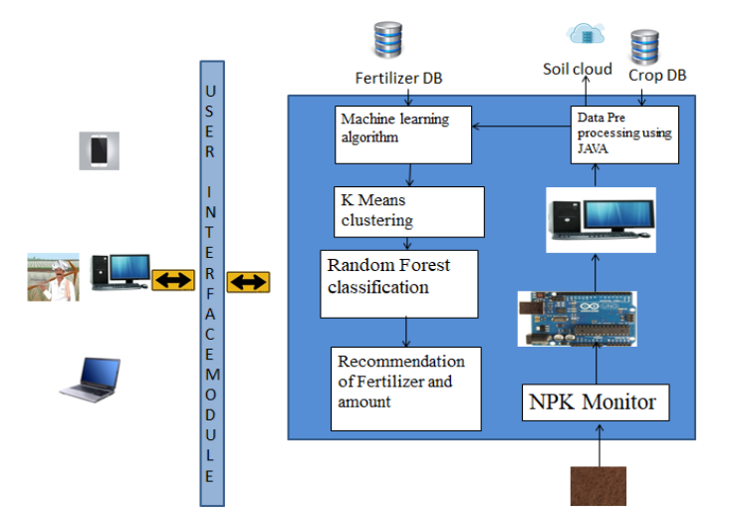
Figure 2: System Architecture

Overview
Machine learning is emerging technology day by day in different fields. But now-a-days agriculture is the sector where machine learning applications are in greater demand. Now the question arises what is machine learning? Actually it is nothing but machine that learns from experiences in order to perform specific task. It provides ability to learn. Huge real time data set is provided to the system.
This data set contains set of attributes called as features. Learning uses these features for further analysis. The performance is measured with performance metric. As more data is added over a time, this performance metric is improved with experience. Various mathematical models are used to calculate performance of machine learning algorithm. Machine learning tasks are broadly classified into supervised learning, unsupervised learning, reinforcement learning, Semi-supervised learning and learning models (classification, regression, clustering, and dimensionality reduction). Table 1.1 describes difference between supervised learning and unsupervised learning.
Table 1.1 Difference between supervised learning and unsupervised learning.
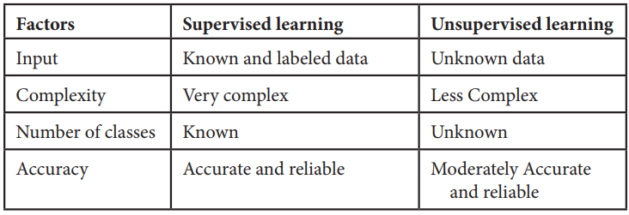
1. Supervised learning:
In supervised learning labelled dataset is used. Here the model is trained on labelled dataset. This dataset contains both input and output parameters. Supervised learning is learning where there is input data, output data and algorithm that maps to input and output. Learning means input and output is provided to machine and machine will develop its own logic for the given task. Some supervised learning algorithms are: Linear Regression, Nearest Neighbour, Gaussian Naive Bayes, Decision Trees, Support Vector Machine (SVM), Random Forest, etc.
The learning is called supervised learning because it is similar to a teacher who is acting as supervisor on entire learning process. The predictions on trained data are generated by learning algorithms. These predictions are corrected by the teacher and learning process is stopped when correct output is achieved [5, 6].
2. Unsupervised learning:
Unsupervised learning is learning that contains only input data and no output data is present. This is applied where there is need to model data distribution in order to get more and more data and there is no any supervisor (like teacher) to supervised the things. Algorithms themselves learn, discover and present structure in data. Here algorithm itself create data pattern. Some recommendation systems for marketing automation use this type of learning.
3. Semi-supervised learning:
The supervised learning has disadvantage that it required labelled dataset. This process is very costly while dealing with large volume of data. Unsupervised learning also has disadvantage that the range of its application is limited. To solve these problems, semi supervised learning algorithms concept was developed. This concept used both labelled data and unlabeled data so that it can work on any type of data. Mostly it contains small amount of labelled data and huge amount of unlabeled data.
Machine Learning Algorithms
There are various machine learning algorithms as described in Figure 1.1 below. These algorithms can be applied in any area to solve various problems.
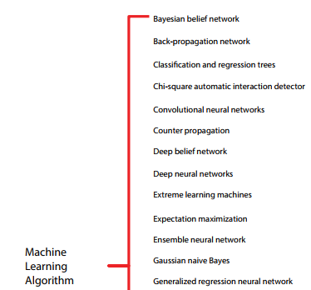
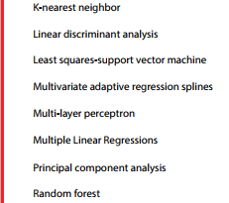
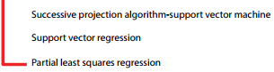
Figure 3: Machine learning algorithms
Machine Learning Methods
There are various Machine learning methods such as boosting techniques (RGF, GBDT, and Ada boost), Regression Tree (ID3, C4.5), Random Forest, SVM, K Nearest Neighbor, and ANN, etc.
CNN
A convolutional neural network (CNN or ConvNet) is a network architecture for deep learning that learns directly from data. CNNs are particularly useful for finding patterns in images to recognize objects, classes, and categories. They can also be quite effective for classifying audio, time-series, and signal data. The pixels from the image are fed to the convolutional layer that performs the convolution operation. It results in a convolved map. The convolved map is applied to a ReLU function to generate a rectified feature map.
The image is processed with multiple convolutions and ReLU layers for locating the features. Convolution is a mathematical operation that allows the merging of two sets of information. In the case of CNN, convolution is applied to the input data to filter the information and produce a feature map. This filter is also called a kernel, or feature detector, and its dimensions can be, for example, 3x3.
A convolutional neural network (CNN or convnet) is a subset of machine learning. It is one of the various types of artificial neural networks which are used for different applications and data types. A CNN is a kind of network architecture for deep learning algorithms and is specifically used for image recognition and tasks that involve the processing of pixel data.
There are other types of neural networks in deep learning, but for identifying and recognizing objects, CNNs are the network architecture of choice. This makes them highly suitable for computer vision (CV) tasks and for applications where object recognition is vital, such as self-driving cars and facial recognition.
Deep learning is a subset of machine learning that uses neural networks with at least three layers. Compared to a network with just one layer, a network with multiple layers can deliver more accurate results. Both RNNs and CNNs are used in deep learning, depending on the application.
For image recognition, image classification and computer vision (CV) applications, CNNs are particularly useful because they provide highly accurate results, especially when a lot of data is involved. The CNN also learns the object's features in successive iterations as the object data moves through the CNN's many layers. This direct (and deep) learning eliminates the need for manual feature extraction (feature engineering).
CNNs can be retrained for new recognition tasks and built on preexisting networks. These advantages open up new opportunities to use CNNs for real-world applications without increasing computational complexities or costs. As seen earlier, CNNs are more computationally efficient than regular NNs since they use parameter sharing. The models are easy to deploy and can run on any device, including smartphones
Support Vector Machines
SVM stands for Support Vector Machine. It is a simple algorithm in machine learning. It belongs to the supervised learning category in
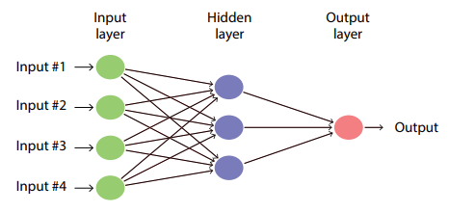
Figure 4: Simple Artificial Neural Network
machine learning which is used for both regression and classification analysis but it is a discriminant classifier which is widely used as classification algorithm. It produces significant accuracy with less computation power. This algorithm is used to create a line or a hyper plane in order to separate the data into various classes. It takes the data as input and outputs a line that separates two classes. It is used in variety of applications such as face detection, classification of emails, news articles, web pages, handwriting recognition.
The use of technology in the detection and analysis process increases the accuracy and reliability of these processes. For example, the people who use the latest technology to analyze the diseases that arise unexpectedly are at a higher chance of controlling them than those that do not. In the recent occurrence of coronavirus, the world relied on the latest technology to develop preventive measures that have helped reduce the rate at which the disease is transmitted. Crop diseases are a significant threat to human existence because they are likely to lead to droughts and famines.
They also cause substantial losses in cases where farming is done for commercial purposes. The use of computer vision (CV) and machine learning (ML) could improve the detection and fighting of diseases. Computer vision is a form of artificial intelligence (AI) that involves using computers to understand and identify objects. It is primarily applied in testing drivers, parking, and driving of self-driven vehicles and now in medical processes to detect and analyze objects [1].
Computer vision helps increase the accuracy of disease protection in plants, making it easy to have food security. One of the areas that CV has helped most is the detection of the severity of the diseases. Deep learning (DL), a part of the CV, is useful and promising in determining the severity of diseases in plants and animals [2]. It is also used to classify diseases and avoid the late detection of diseases [1]. Plant diseases are slightly different from those that affect human beings. Many factors make diseases similar as well. However, the diseases that can be transmitted from humans to plants and vice versa are rare.
The analysis of the data related to this field helps identify how the use of the latest technology can be improved. The images of leaves and other parts of the plants can be used to detect diseases in plants [3]. The technology could be applied in analyzing images in human beings that also prove the presence of diseases and determine the extent of their destruction. This research study is aimed at analyzing the way image-based technology can be used in detecting diseases in both plants and animals.
ML is the technology that allows machines to communicate with human beings and understand their needs. It also makes machines act like human beings and make the decision on behalf of humans. It is one of the areas that have grown fast over the past few years. ML helps in classifying plant diseases. The use of this technology is seen as a significant beginning and achievement in dealing with plant diseases. It has also increased productivity in the field of cultivation.
Visualization techniques have also been included in this technology, and it has been improved over the last three years to the current improved levels [4]. The challenges that face the world today, related to the diseases affecting plants and humans, can be reduced if the diseases are identified before they spread to vast areas. The use of ML is widespread in the world today. Diverse methods used in ML and DL help the experts to analyze the plant diseases and know their source in time [4]. The detection of these diseases is affected mainly by several challenges that affect the effectiveness and accuracy of this technology.
The first challenge is the time complexity associated with the use of ML and DL, whereby some of the technologies used in the detection of these diseases are outdated or based on some information from the past. The other challenge is segmentation sensitivity [5]. It means that the region of interest (RoI) requires a high level of accuracy and sensitivity to acquire the required usage and accuracy. The other challenge is that there is a language barrier that affects the way the technology is applied. Another challenge is the inadequate resources that are required to support the application of this technology.
Most of the ML and DL activities need many resources to use and implement. Private and government entities usually fund the institutes that use this technology to detect diseases in humans and plants, which could affect the success of the research and implementation of the technology. The importance of plants in the world has increased over time. The discoveries about the critical roles that plants could play in medicine, energy production, and the recent concerns about the reduction of global warming have for long been a significant part of science and technology [6].
A reduction in the plant cover in the world increases the risk of higher global warming and an increase in the related challenges. The need to build a state-of-the-art convolutional system that supports the image detection technology and classification of plant diseases has led to many research programs to provide the scientists with the required knowledge [7]. Image detection could be applied when necessary to differentiate healthy leaves from those that are not healthy.
The convolutional neural networks (CNNs) provide the differences among plant images that help determine the abnormalities that could exist in the plants in the natural environment [6]. The background study shows that the scanning of the images that show the healthy and unhealthy plants forms a basis for comparison by the scientists in this field. DL can be used to detect abnormalities in both humans and plants. The pixel-wise operations are used to analyze the leaves collected from sick plants, and this is used to classify the diseases according to their impact on the plants.
The visible patterns in these leaves are used to decide the diseases that affect the plants and how they can be dealt with to prevent them from spreading. Research shows that the use of DL technology is up to 98.59% accurate [8]. The field of plant pathology has contributed immensely to the control of diseases and reduced global warming. One of the essential background knowledge that guides the use of image detection technology is that the leaves of the infected plants are different from the healthy ones.
The leaves are likely to have dark parts, and some may be dry along the edges. The dried parts are also likely to fold up, and this is easy to detect even with a bare eye. The use of ML is to detect these differences without human intervention. The ML methods used to make decisions on the detection of diseases include Central Neural Networks (CNN), decision trees, support vector machines (SVM), and K-means, among others [9]. The computers may not work directly with the images taken in the fields.
The images are converted into data that the machines and computers can interpret. It means that the technology requires the coding of the images into data that can be fed into the computer systems. Therefore, the basic knowledge in computer codes and programming forms an integral part of the background knowledge required in this field. Apart from the aforementioned application of the knowledge in plants and detecting the diseases on time, the image-based detection and recognition of diseases are applied in humans to detect the diseases that affect different body parts. Some human diseases have significant impacts on the tissues and organs that they affect.
Adenocarcinoma of the prostate is one of the most common forms of cancer. It is detected using the image-based detection methods whereby the body is scanned for the abnormalities and the images obtained are used to determine if the patient has the disease. It is the second most diagnosed type of cancer in men, with about one in every nine men diagnosed with it in their lifetime [10]. The use of subjective tissue examination has been the primary way of detecting cancer in men suspected of it. The examination of these body tissues is largely dependent on the Gleason system [11].
The field of AI has offered many solutions to the challenge of inaccuracy in the Gleason scale and how it is used to provide solutions to people who have prostate cancer. The AI solutions are applied in analyzing the prostatectomy specimens to determine the impact of cancer on them. Before and after they have been affected by a disease like cancer, the appearance of the body organs is used to design the image-based detection process that is more accurate than the human eyes. In other words, computer systems can detect the difference in the organs more efficiently than humans.
It helps to detect the disease long before they get to a fatal stage. As for some plants like Cassava, it is possible to provide some protection to them from common diseases through image-based detection technology. Agriculture depends on some drought-resistant crops like Cassava to regulate the food supply and ensure an adequate supply of nutrients [12]. However, diseases threaten some of these crops’ survival, which makes it hard for the agriculture departments to meet their targets. The background knowledge about the diseases could help avoid such instances.
The use of CNN generates a reliable platform where the diseases are analyzed in detail [13]. The accuracy of this method is high and reliable. Further research by experts on the diseases that affect plants like Cassava has classified the diseases in terms of their impact on the leaves and other parts of the plants [14]. For example, many diseases affect the part of the leaves, some affect the entire leaf, and others attack the edges or the stalk. The images of the leaves can be analyzed using the image-based detection system to determine the classification that suits the disease.
In places like sub-Saharan Africa, Cassava is one of the essential foods because it provides people with many carbohydrates. However, due to its vulnerability to viral diseases, it has not effectively sustained the nutritional value it could achieve in this region. In 2014, about 145 million tons of Cassava was harvested in Africa [13]. The food control methods applied in the world today mainly focus on increasing production.
The application of the latest technology to detect and control the disease that affects production is a reliable way of reducing the challenges of food inadequacy. Most of the plants are also used as raw materials in many industries. If such plants are of low quality, it means that they will lead to the production of low-standard products.
Fungi usually cause diseases that affect the plants, and they typically attack the leaves. Viral and bacterial pathogens cause many others. Precision in agriculture has improved with the increased use of ML and its related features [15]. The reduced production quantity in agriculture hurts many people and animals, which requires modern technology to solve. The extraction and detection of diseases are easier when the image-based detection system is used because of its high accuracy and reduced complications and duplication of data.
In some plants like tomatoes, the use of the images to determine the diseases that affect them and the extent of the damages cannot be achieved unless there is a high accuracy rate [16]. The survey on plant diseases shows that many diverse factors determine how technology-based image detection is applied. In other words, the diseases that cause visible dents and changes on the plants are the ones that can be detected using this technology as opposed to the ones that cause damages that cannot be detected from the plants’ images [17]. The analysis in this research shows that plant diseases are usually detected when they start showing an impact on the physical appearance of the plants.
The main challenge affecting the field of agriculture is the reduction in production and poor-quality production in plants. The challenge is a result of the poor detection and management of the diseases that affect the plants. The challenge is also extended to affect human beings in several ways. The reduced plant cover due to plant diseases means that global warming, famine, and reduced air purification ensue. Hyper spectral imaging has become a reliable way of detecting crop diseases on time [18].
It is hard to determine the factors that lead to the diseases unless they are detected on time. In other words, if a disease is detected on time, it is easy to relate it to the possible factors that lead to its occurrence. For example, scientists could determine if there was a change in weather or climate that could have led to the occurrence of the disease. Further research by [6] shows an inadequate database that could be used to provide background knowledge for comparing the images taken.
The other challenge is that the symptoms and characteristics of the diseases are diverse and could be similar to a certain degree [19]. For example, many diseases could lead to the wilting of leaves. The challenge is yet to be resolved because more and new images are uploaded progressively by experts. The other challenge is the lack of suitable instruments for use in the work of image detection. Most of the experts in the field do not have the equipment they require to analyze the images they get from the field, and this makes it hard for them to acquire accurate data and identify the diseases [20].
The other one is that there is a low rate of implementation in some areas due to the regulations put in place to ensure the credibility and reliability of the data from these analyses. For example, after the 4th and 6th International Conference on Machine Learning and Soft Computing, there have been many regulations that may derail the use of ML in some parts [21]. The rules discourage some of the results from the ML functions from being applied in practice because they do not meet the required parameters. The technology has been in existence for several years now.
However, there are still many issues that have not been clarified about its application. The other challenge is related to this fact. Some of the important images that could help determine if disease exists have not been captured. The other one is that the future perspectives of the research are not clear, and this is because of the increased diversity in the diseases that affect both humans and animals [19]. The application of image-based detection is also affected by the increased diversity in the way the diseases appear. Some of the diseases that used to affect the plants a few years ago have evolved into new forms, and they have different impacts and outcomes.
It is difficult for the images to be used alone to conclude the diseases and choose a solution. Some of the solutions used in the past have also become ineffective, reducing the effectiveness of the technology. The aforementioned challenges show that there are many possible ways in which the image-based detection could be applied, but the challenges reduce its usability. The first solution is to provide adequate data that can be used to identify the diseases accurately without confusing the ones that are closely related.
The changes in weather, global warming, and other impacts have led to many diseases that have not been documented. The solution is to increase scientists’ coverage and promote a better way of collecting information [22]. The other solution would be to offer training to the scientists in this field to ensure that they are equipped to collect the data. Yet another solution is to create better ways of capturing the data collected about the diseases.
The challenge of inadequate information about the diseases can be solved if there is an improved data-captioning process that involves fine details of the images taken and the differences that define them [6]. The images should be analyzed keenly to determine the ones that are affected or infected.
Another solution would be to focus on using the latest technology that is reliable and valid. The confusion that comes with the inadequate database for use in detecting the diseases results from inferior technology and low storage abilities of the existing systems. Most of the images are not stored correctly, which affects the accessibility of the information. It could be solved by the use of modern methods of storing information. For example, the use of cloud computing could help increase the accuracy of storage and accessibility. The other solution is training the people in charge of the research and analysis of the information.
A trained DL algorithm increases the accuracy of the technology [23]. The other solution would be to understand the phenotypes used in detecting diseases [24]. The phenotype used in the detection of diseases is usually a result of climate and weather [23, 25]. The other solution would be to update the systems to ensure the data captured is up to date. The high level of uncertainty in the detection of diseases affects the way the technology is implemented. For example, the use of Bayesian DL is associated with several uncertainties [26]. It means that this method is unreliable if used alone.
A combination of several methods could reduce the inefficiencies of the processes. For example, the application of DL meta-architectures provides a solution to some of the errors that are experienced when using other methods of identifying diseases [27]. The other solution would be the application of deep convolutional generative adversarial networks that help in the identification and analysis of the images [28]. The contribution of the adversarial networks increases the accuracy of the detection process.
The use of CNN methods could also be effective in dealing with the inaccuracy and slow identification processes of the diseases [29]. The methods have been used to detect the diseases that affect rice and have many benefits [28]. Image-based detection requires many resources, and the authorities should ensure they are available to ensure the activities are smooth.

  - System Requirements
A Software requirements specification (SRS) document describes the intended purpose, requirements, and nature of software/application/project to be developed. To prepare an SRS document, you would need to have a functional knowledge of your project or application, knowledge of software/hardware/technology to be used.

    - Hardware Requirements
- System Processor : Pentium IV 2.4 GHz or above
- Hard Disk : 20 GB or above
- Monitor : 10/12/15 VGA color
- Mouse : Three button windows standard mouse
- Keyboard : Windows standard keyboard.
- Ram : 4GB or above
3.2.2 Software Requirements
- Operating system : Windows 7/8/10/11.
- Programming Language : python 3.7
- IDE : PyCharm Community Edition
- Type of Application : Graphical User Interface
- Frontend Technologies : Tkinter, API, CNN with supported libraries
- Backend Technologies : matplotlib, TensorFlow, Keras, etc.
- Dataset : Healthy and Unhealthy Plant Disease Dataset

CHAPTER-4: INPUT AND OUTPUT DESIGN

4.1 Input Design
The input design is the link between the information system and the user. It comprises the developing specification and procedures for data preparation and those steps are necessary to put transaction data in to a usable form for processing can be achieved by inspecting the computer to read data from a written or printed document or it can occur by having people keying the data directly into the system. The design of input focuses on controlling the amount of input required, controlling the errors, avoiding delay, avoiding extra steps and keeping the process simple. The input is designed in such a way so that it provides security and ease of use with retaining the privacy. Input Design considered the following things:
- What data should be given as input?
- How the data should be arranged or coded?
- The dialog to guide the operating personnel in providing input.
- Methods for preparing input validations and steps to follow when error occur.

OBJECTIVES
1.Input Design is the process of converting a user-oriented description of the input into a computer-based system. This design is important to avoid errors in the data input process and show the correct direction to the management for getting correct information from the computerized system.
2. It is achieved by creating user-friendly screens for the data entry to handle large volume of data. The goal of designing input is to make data entry easier and to be free from errors. The data entry screen is designed in such a way that all the data manipulates can be performed. It also provides record viewing facilities.
3.When the data is entered it will check for its validity. Data can be entered with the help of screens. Appropriate messages are provided as when needed so that the user will not be in maize of instant. Thus the objective of input design is to create an input layout that is easy to follow

4.2 Output Design
A quality output is one, which meets the requirements of the end user and presents the information clearly. In any system results of processing are communicated to the users and to other system through outputs. In output design it is determined how the information is to be displaced for immediate need and also the hard copy output. It is the most important and direct source information to the user. Efficient and intelligent output design improves the system’s relationship to help user decision-making.
1. Designing computer output should proceed in an organized, well thought out manner; the right output must be developed while ensuring that each output element is designed so that people will find the system can use easily and effectively. When analysis design computer output, they should Identify the specific output that is needed to meet the requirements.
2.Select methods for presenting information.
3.Create document, report, or other formats that contain information produced by the system.
The output form of an information system should accomplish one or more of the following objectives.
- Convey information about past activities, current status or projections of the
- Future.
- Signal important events, opportunities, problems, or warnings.
- Trigger an action.
- Confirm an action.

CHAPTER-5: SYSTEM ENVIRONMENT

5.1 PYTHON
Python is a high-level, interpreted, interactive and object-oriented scripting language. Python is designed to be highly readable. It uses English keywords frequently where as other languages use punctuation, and it has fewer syntactical constructions than other languages.
- Python is Interpreted: Python is processed at runtime by the interpreter. You do not need to compile your program before executing it. This is similar to PERL and PHP.
- Python is Interactive: You can actually sit at a Python prompt and interact with the interpreter directly to write your programs.
- Python is Object-Oriented: Python supports Object-Oriented style or technique of programming that encapsulates code within objects.
- Python is a Beginner's Language: Python is a great language for the beginner-level programmers and supports the development of a wide range of applications from simple text processing to WWW browsers to games.

5.1.1 History of Python

Python was developed by Guido van Rossum in the late eighties and early nineties at the National Research Institute for Mathematics and Computer Science in the Netherlands.
Python is derived from many other languages, including ABC, Modula-3, C, C++, Algol-68, SmallTalk, and Unix shell and other scripting languages.
Python is copyrighted. Like Perl, Python source code is now available under the GNU General Public License (GPL).
Python is now maintained by a core development team at the institute, although Guido van Rossum still holds a vital role in directing its progress.

5.1.2 What can python do
Python is a versatile and powerful programming language that can accomplish a wide array of tasks, making it a popular choice across various domains. In the realm of software development, Python can be used to build web applications, desktop software, and network servers, leveraging frameworks like Django and Flask for web development. Its simplicity and readability make it an excellent language for rapid prototyping and scripting, enabling developers to automate repetitive tasks and streamline workflows. Python's extensive standard library and numerous third-party packages support data analysis and scientific computing, with tools like NumPy, pandas, and Matplotlib facilitating complex data manipulation and visualization. In the field of artificial intelligence and machine learning, Python is the language of choice, with libraries such as TensorFlow, PyTorch, and scikit-learn providing robust tools for building and deploying sophisticated models. Additionally, Python's support for cross-platform compatibility ensures that applications and scripts can run on various operating systems without significant modifications. Overall, Python's flexibility, ease of use, and strong community support make it a go-to language for a diverse range of programming tasks and projects.
5.1.3 Why python
Python's widespread adoption and enduring popularity can be attributed to several key factors that make it an exceptional choice for both novice and experienced programmers. One of the primary reasons for Python's appeal is its simplicity and readability. The language's syntax is designed to be intuitive and clear, resembling natural language, which simplifies the learning curve and enhances code maintainability. This readability also fosters collaboration, as it allows developers to easily understand and contribute to each other's codebases.
Another significant advantage of Python is its extensive standard library and the vast ecosystem of third-party packages. This wealth of resources covers a multitude of functionalities, from web development and data analysis to machine learning and automation, enabling developers to leverage pre-built tools and modules to expedite development and reduce the need for reinventing the wheel.
Python's versatility is another compelling reason for its popularity. It is a general-purpose language that can be applied to a wide range of applications, from small scripts to large-scale enterprise systems. Its support for multiple programming paradigms, including procedural, object-oriented, and functional programming, allows developers to choose the most appropriate approach for their projects.
5.1.4 Python syntax compared to other programming languages
Python's syntax stands out among programming languages for its emphasis on simplicity and readability. Unlike languages such as C++ or Java, which often require verbose code and explicit type declarations, Python adopts a minimalist approach with significant use of whitespace to delimit blocks of code, eliminating the need for braces or semicolons that can clutter the code in other languages. This indentation-based syntax not only makes the code visually cleaner but also enforces a clear structure that can reduce errors and enhance readability.

Python's syntax is designed to be intuitive, with a focus on natural language expressions. For example, its use of English keywords like 'and', 'or', and 'not' instead of symbols makes the code more approachable for beginners and easier to understand for all developers. Additionally, Python's dynamic typing allows for more flexible coding, as variables do not need to be explicitly declared with a type, which can speed up development and reduce boilerplate code.

In contrast to more rigid languages, Python's syntax encourages modularity and code reuse through its support for high-level data types and operations, such as list comprehensions and dictionary manipulations, which can replace multiple lines of code in other languages with a single, concise expression. This conciseness not only saves time but also reduces the potential for errors.

Moreover, Python's extensive use of libraries and modules, which are imported with simple and consistent syntax, facilitates the integration of complex functionalities with minimal code. This ease of use and integration is a significant factor in Python's popularity across various domains, from web development to scientific computing and machine learning.

5.1.5 Uses of Python
Python is renowned for its versatility and is employed across a broad spectrum of applications. In the realm of web development, Python powers dynamic websites and web applications through frameworks like Django and Flask, offering robust tools for backend development, API creation, and database management. Its scripting capabilities make it indispensable for automating routine tasks, from file manipulation to system administration, enhancing productivity and efficiency.

In the scientific and numerical computing domain, Python is a go-to language, thanks to libraries such as NumPy, pandas, and SciPy, which facilitate data analysis, statistical modeling, and numerical computations. Its visualization tools, like Matplotlib and seaborn, enable the creation of insightful data visualizations, aiding in research and decision-making processes.

Python's prowess extends to artificial intelligence and machine learning, where libraries like TensorFlow, PyTorch, and scikit-learn are used to build, train, and deploy complex models for tasks such as image recognition, natural language processing, and predictive analytics. Its simplicity and flexibility make it an ideal language for rapid prototyping and experimentation in these fields.

Additionally, Python is widely used in education and academia for teaching programming concepts due to its clear syntax and ease of learning. It also plays a crucial role in the finance industry, where it is used for quantitative analysis, algorithmic trading, and risk management.

5.1.6 Python Features
Python's features include:
- Easy-to-learn: Python has few keywords, simple structure, and a clearly defined syntax. This allows the student to pick up the language quickly.
- Easy-to-read: Python code is more clearly defined and visible to the eyes.
- Easy-to-maintain: Python's source code is fairly easy-to-maintain.
- A broad standard library: Python's bulk of the library is very portable and cross-platform compatible on UNIX, Windows, and Macintosh.

- Interactive Mode: Python has support for an interactive mode which allows interactive testing and debugging of snippets of code.
- Portable: Python can run on a wide variety of hardware platforms and has the same interface on all platforms.
- Extendable: You can add low-level modules to the Python interpreter. These modules enable programmers to add to or customize their tools to be more efficient.
- Databases: Python provides interfaces to all major commercial databases.
- GUI Programming: Python supports GUI applications that can be created and ported to many system calls, libraries and windows systems, such as Windows MFC, Macintosh, and the X Window system of Unix.
- Scalable: Python provides a better structure and support for large programs than shell scripting.
Python has a big list of good features:
- It supports functional and structured programming methods as well as OOP.
- It can be used as a scripting language or can be compiled to byte-code for building large applications.
- It provides very high-level dynamic data types and supports dynamic type checking.
- IT supports automatic garbage collection.
- It can be easily integrated with C, C++, COM, ActiveX, CORBA, and Java.

5.2 SDLC

5.2.1 Benefits of SDLC
The Software Development Life Cycle (SDLC) is a structured process that guides the development of software from inception to retirement. It encompasses various phases, including planning, design, development, testing, deployment, and maintenance. The benefits of adhering to an SDLC approach are numerous and contribute to the successful delivery and management of software projects. Here are some key advantages:

Improved Planning and Organization: SDLC provides a systematic framework that helps in defining project scope, objectives, and deliverables. This structured approach ensures that all stakeholders have a clear understanding of the project's goals and the steps required to achieve them.

Enhanced Quality and Reliability: By incorporating rigorous testing phases, SDLC ensures that software is thoroughly checked for bugs and errors before it is released. This leads to higher quality products that are more reliable and perform better in real-world scenarios.

Increased Efficiency and Productivity: The SDLC's phased approach allows for better resource allocation and task management. It helps in identifying bottlenecks and inefficiencies early in the process, enabling teams to optimize their workflows and improve productivity.

Better Risk Management: SDLC facilitates the early identification and mitigation of risks through regular reviews and checkpoints. This proactive approach helps in minimizing the impact of potential issues and ensures that the project stays on track.

Enhanced Collaboration and Communication: The structured nature of SDLC promotes clear communication among team members, stakeholders, and clients. It provides a common framework for discussing progress, challenges, and decisions, which leads to better collaboration and alignment.

Cost-Effectiveness: By planning and managing resources effectively, SDLC helps in controlling costs. It ensures that the project stays within budget by preventing scope creep and reducing the need for rework due to undetected issues.

Scalability and Flexibility: SDLC methodologies, such as Agile and DevOps, emphasize iterative development and continuous improvement. This allows for greater flexibility in adapting to changing requirements and scaling the project as needed.

Documentation and Knowledge Transfer: SDLC emphasizes the importance of documentation at each phase. This ensures that knowledge is captured and can be easily transferred, facilitating onboarding of new team members and providing a reference for future projects.

Customer Satisfaction: By delivering high-quality software that meets customer needs and expectations, SDLC contributes to higher customer satisfaction. The iterative and customer-centric approaches ensure that feedback is incorporated throughout the development process.

Lifecycle Management: SDLC extends beyond the initial development phase to include maintenance and updates. This ensures that the software remains relevant, secure, and functional over its entire lifecycle, providing long-term value to the organization.

5.3 Natural Language Processing (NLP)
Natural Language Processing (NLP) is a branch of artificial intelligence (AI) that focuses on the interaction between computers and humans through natural language. The ultimate objective of NLP is to enable computers to understand, interpret, and respond to human language in a way that is both meaningful and contextually appropriate. NLP combines computational linguistics—rule-based modeling of human language—with statistical, machine learning, and deep learning models to process and analyze large volumes of natural language data.
Key components and applications of NLP include:
Language Modeling: This involves creating models that can predict the next word or phrase in a sequence, which is fundamental for tasks like speech recognition, machine translation, and text generation.
Speech Recognition: NLP techniques are used to convert spoken language into text, enabling applications like virtual assistants (e.g., Siri, Alexa) and dictation software.
Machine Translation: NLP powers automated translation services that can convert text from one language to another, such as Google Translate, facilitating cross-language communication.
Sentiment Analysis: NLP can analyze text to determine the emotional tone behind words, helping businesses understand customer feedback, social media sentiment, and public opinion.
Text Classification: NLP is used to categorize text into different classes or categories, which is useful for spam filtering, topic labeling, and content recommendation.
Information Extraction: NLP techniques can extract structured information from unstructured text, such as identifying names, dates, and places in news articles or research papers.
Question Answering: NLP systems can parse and understand questions posed in natural language and provide relevant answers, as seen in chatbots and virtual customer service agents.
Summarization: NLP can generate concise summaries of longer documents or articles, saving time for readers and helping to distill key information.
Dialogue Systems: These are conversational agents that use NLP to understand and respond to user inputs, facilitating interactive experiences in applications like customer service and virtual assistants.
Named Entity Recognition (NER): NLP can identify and classify named entities in text into predefined categories such as names of persons, organizations, locations, dates, etc.
NLP technologies are continuously evolving, with advancements in deep learning and neural network architectures leading to significant improvements in the accuracy and sophistication of NLP applications. These developments are paving the way for more natural and intuitive human-computer interactions, enhancing the capabilities of AI systems across various domains.
5.4 Similarity Measures
Similarity measures are mathematical techniques used to quantify how alike two data objects are. In various fields such as data science, machine learning, information retrieval, and natural language processing, similarity measures play a crucial role in clustering, classification, recommendation systems, and pattern recognition. Here are some common types of similarity measures:
Euclidean Distance: This is a straightforward measure that calculates the straight-line distance between two points in a multi-dimensional space. It is widely used in geometry and can be applied to continuous data.
Cosine Similarity: This measure computes the cosine of the angle between two vectors. It is particularly useful in text analysis and recommendation systems, where the magnitude of the vectors is less important than their direction. Cosine similarity ranges from -1 (completely dissimilar) to 1 (completely similar), with 0 indicating orthogonality.
Jaccard Index: Also known as the Jaccard similarity coefficient, this measure is used for comparing the similarity and diversity of sample sets. It is defined as the size of the intersection divided by the size of the union of the sample sets. It is commonly used in data clustering and segmentation tasks.
Pearson Correlation Coefficient: This measure assesses the linear relationship between two continuous variables. It ranges from -1 to 1, where 1 indicates a perfect positive linear relationship, -1 indicates a perfect negative linear relationship, and 0 indicates no linear relationship.
Manhattan Distance: Also known as the city block distance or L1 norm, this measure calculates the distance between two points as the sum of the absolute differences of their coordinates. It is useful in cases where the path between points is constrained, such as in grid-like structures.
Hamming Distance: This measure counts the number of positions at which the corresponding symbols (bits) in two strings of equal length are different. It is commonly used in information theory and coding theory.
Mahalanobis Distance: This measure considers the correlation between variables and is scale-invariant. It is particularly useful when dealing with multivariate data that may have different variances and correlations among variables.
Edit Distance (Levenshtein Distance): This measure calculates the minimum number of single-character edits (insertions, deletions, or substitutions) required to change one word into another. It is used in applications like spell checking and DNA sequence alignment.
Dice's Coefficient: Similar to the Jaccard Index, Dice's Coefficient measures the similarity between two sets and is often used in image segmentation and text mining.
Kernel Functions: These are similarity measures used in machine learning to map data into a higher-dimensional space where it can be more easily separated or clustered. Common kernel functions include the Gaussian (RBF) kernel and polynomial kernel.
The choice of similarity measure depends on the nature of the data and the specific requirements of the application. Proper selection and tuning of these measures can significantly impact the performance of algorithms that rely on them.

CHAPTER-6: SYSTEM STUDY
6.1 Economic Feasibility
This study is carried out to check the economic impact that the system will have on the organization. The amount of fund that the company can pour into the research and development of the system is limited. The expenditures must be justified. Thus the developed system as well within the budget and this was achieved because most of the technologies used are freely available. Only the customized products had to be purchased.
6.2 Technical Feasibility
This study is carried out to check the technical feasibility, that is, the technical requirements of the system. Any system developed must not have a high demand on the available technical resources. This will lead to high demands on the available technical resources. This will lead to high demands being placed on the client. The developed system must have a modest requirement, as only minimal or null changes are required for implementing this system.
6.3 Social Feasibility
The aspect of study is to check the level of acceptance of the system by the user. This includes the process of training the user to use the system efficiently. The user must not feel threatened by the system, instead must accept it as a necessity. The level of acceptance by the users solely depends on the methods that are employed to educate the user about the system and to make him familiar with it. His level of confidence must be raised so that he is also able to make some constructive criticism, which is welcomed, as he is the final user of the system.

CHAPTER-7: SYSTEM TESTING
7.1 Types of Tests
7.1.1 Unit testing
Unit testing involves the design of test cases that validate that the internal program logic is functioning properly, and that program inputs produce valid outputs. All decision branches and internal code flow should be validated. It is the testing of individual software units of the application .it is done after the completion of an individual unit before integration. This is a structural testing, that relies on knowledge of its construction and is invasive. Unit tests perform basic tests at component level and test a specific business process, application, and/or system configuration. Unit tests ensure that each unique path of a business process performs accurately to the documented specifications and contains clearly defined inputs
7.1.2 Integration testing
Integration tests are designed to test integrated software components to determine if they actually run as one program. Testing is event driven and is more concerned with the basic outcome of screens or fields. Integration tests demonstrate that although the components were individually satisfaction, as shown by successfully unit testing, the combination of components is correct and consistent. Integration testing is specifically aimed at exposing the problems that arise from the combination of components.

7.1.3 Functional testing

Functional tests provide systematic demonstrations that functions tested are available as specified by the business and technical requirements, system documentation, and user manuals.
Functional testing is centered on the following items:
Valid Input : identified classes of valid input must be accepted.
Invalid Input : identified classes of invalid input must be rejected.
Functions : identified functions must be exercised.
Output : identified classes of application outputs must be exercised.
Systems/Procedures : interfacing systems or procedures must be invoked.
Organization and preparation of functional tests is focused on requirements, key functions, or special test cases. In addition, systematic coverage pertaining to identify Business process flows; data fields, predefined processes, and successive processes must be considered for testing. Before functional testing is complete, additional tests are identified and the effective value of current tests is determined.

7.1.4 System testing
System testing ensures that the entire integrated software system meets requirements. It tests a configuration to ensure known and predictable results. An example of system testing is the configuration oriented system integration test. System testing is based on process descriptions and flows, emphasizing pre-driven process links and integration points.

7.1.5 Acceptance testing
User Acceptance Testing is a critical phase of any project and requires significant participation by the end user. It also ensures that the system meets the functional requirements.
Test Results: All the test cases mentioned above passed successfully. No defects encountered.

CHAPTER-8: SOURCE CODE

# Import necessary libraries
from pathlib import Path
from tkinter import Tk, Canvas, Entry, Text, Button, PhotoImage, messagebox, simpledialog, filedialog
import tkinter as tk
import numpy as np
import matplotlib.pyplot as plt
import pandas as pd
from sklearn.metrics import accuracy_score, precision_score, recall_score, f1_score
from sklearn.model_selection import train_test_split
import os
import pickle
import cv2
from skimage import color
from skimage.feature import greycomatrix, greycoprops
import scipy.stats as stats
from sklearn import svm
from sklearn.neighbors import KNeighborsClassifier
from sklearn.neural_network import MLPClassifier
from tensorflow.keras.utils import to_categorical
from tensorflow.keras.layers import MaxPooling2D, Dense, Dropout, Activation, Flatten, Convolution2D
from tensorflow.keras.models import Sequential, model_from_json

# Define paths for assets and output
OUTPUT_PATH = Path(__file__).parent
ASSETS_PATH = OUTPUT_PATH / Path(r"assets/frame0/")

def relative_to_assets(path: str) -> Path:
return ASSETS_PATH / Path(path)

# Global variables
global filename
global X, Y
accuracy = []
precision = []
recall = []
fscore = []
global X_train, X_test, y_train, y_test
global cnn

# Define labels and corresponding fertilizers
labels = ['Chilli___Bacterial_spot', 'Chilli___healthy', 'Cotton___Black_rot', 'Cotton___Esca_(Black_Measles)', 'Cotton___healthy', 'Cotton___Leaf_blight_(Isariopsis_Leaf_Spot)',
'Rice___Brownspot', 'Rice___Healthy', 'Rice___Leafblast', 'Rice___Leafblight', 'Tomato___Bacterial_spot', 'Tomato___Early_blight',
'Tomato___healthy', 'Tomato___Late_blight', 'Tomato___Leaf_Mold', 'Tomato___Septoria_leaf_spot',
'Tomato___Spider_mites Two-spotted_spider_mite', 'Tomato___Target_Spot', 'Tomato___Tomato_mosaic_virus', 'Tomato___Tomato_Yellow_Leaf_Curl_Virus']

fertilizers = ['Twice in a month,Mancozeb', 'No fertlizers required', 'Thielaviopsis', 'Fungiside', 'No fertlizers required', 'Micronutrients based Fertilizer',
'Fertlizers with N,P,K', 'No fertlizers required', 'Magnaporthe Oryzae', 'Xanthomous Oryzae', 'Balanced Fertilizer(N,P,K)', 'Micronutrients',
'No fertlizers required', 'Pathogen related', 'Fungicides Related', 'Balanced Fertilizer(N,P,K)',
'Natural Predators', 'Pttasium', 'Weed Control based', 'Organic Mulch']

# Load the pre-trained CNN model
with open('model/model.json', "r") as json_file:
loaded_model_json = json_file.read()
cnn_classifier = model_from_json(loaded_model_json)
json_file.close()
cnn_classifier.load_weights("model/model_weights.h5")

########################################################################################################################
# Function to remove green pixels from the image
def remove_green_pixels(image):
channels_first = channels_first_transform(image)
r_channel = channels_first[0]
g_channel = channels_first[1]
b_channel = channels_first[2]
mask = False == np.multiply(g_channel > r_channel, g_channel > b_channel)
channels_first = np.multiply(channels_first, mask)
image = channels_first.transpose(1, 2, 0)
return image

# Function to convert RGB image to LAB color space
def rgb2lab(image):
return color.rgb2lab(image)

# Function to convert RGB image to grayscale
def rgb2gray(image):
return np.array(color.rgb2gray(image) * 255, dtype=np.uint8)

# Function to compute GLCM (Gray Level Co-occurrence Matrix)
def glcm(image, offsets=[1], angles=[0], squeeze=False):
single_channel_image = image if len(image.shape) == 2 else rgb2gray(image)
gclm = greycomatrix(single_channel_image, offsets, angles)
return np.squeeze(gclm) if squeeze else gclm

# Function to compute histogram features with bucket count
def histogram_features_bucket_count(image):
image = channels_first_transform(image).reshape(3, -1)
r_channel = image[0]
g_channel = image[1]
b_channel = image[2]
r_hist = np.histogram(r_channel, bins=26, range=(0, 255))[0]
g_hist = np.histogram(g_channel, bins=26, range=(0, 255))[0]
b_hist = np.histogram(b_channel, bins=26, range=(0, 255))[0]
return np.concatenate((r_hist, g_hist, b_hist))

# Function to compute histogram features
def histogram_features(image):
color_histogram = np.histogram(image.flatten(), bins=255, range=(0, 255))[0]
return np.array([
np.mean(color_histogram),
np.std(color_histogram),
stats.entropy(color_histogram),
stats.kurtosis(color_histogram),
stats.skew(color_histogram),
np.sqrt(np.mean(np.square(color_histogram)))
])

# Function to compute texture features
def texture_features(full_image, offsets=[1], angles=[0], remove_green=True):
image = remove_green_pixels(full_image) if remove_green else full_image
gray_image = rgb2gray(image)
glcmatrix = glcm(gray_image, offsets=offsets, angles=angles)
return glcm_features(glcmatrix)

# Function to compute GLCM features
def glcm_features(glcm):
return np.array([
greycoprops(glcm, 'correlation'),
greycoprops(glcm, 'contrast'),
greycoprops(glcm, 'energy'),
greycoprops(glcm, 'homogeneity'),
greycoprops(glcm, 'dissimilarity'),
]).flatten()

# Function to transform image to channels first format
def channels_first_transform(image):
return image.transpose((2, 0, 1))

# Function to extract features from the image
def extract_features(image):
offsets = [1, 3, 10, 20]
angles = [0, np.pi / 4, np.pi / 2]
channels_first = channels_first_transform(image)
return np.concatenate((
texture_features(image, offsets=offsets, angles=angles),
texture_features(image, offsets=offsets, angles=angles, remove_green=False),
histogram_features_bucket_count(image),
histogram_features(channels_first[0]),
histogram_features(channels_first[1]),
histogram_features(channels_first[2]),
))

# Function to get the index of a label
def getID(name):
index = 0
for i in range(len(labels)):
if labels[i] == name:
index = i
break
return index

# Function to upload dataset
def uploadDataset():
global filename
filename = filedialog.askdirectory(initialdir=".")
entry_1.delete('1.0', tk.END)
entry_1.insert(tk.END, filename + ' Loaded\n\n')
entry_1.insert(tk.END, "Different Diseases Found in Dataset : " + str(labels) + "\n\n")
entry_1.insert(tk.END, "Total diseases are : " + str(len(labels)))

# Function to extract features from the dataset
def featuresExtraction():
global filename
global X, Y
global X_train, X_test, y_train, y_test
entry_1.delete('1.0', tk.END)
if os.path.exists("model/X.npy"):
X = np.load('model/X.npy')
Y = np.load('model/Y.npy')
else:
X = []
Y = []
for root, dirs, directory in os.walk(filename):
for j in range(len(directory)):
name = os.path.basename(root)
if 'Thumbs.db' not in directory[j]:
img = cv2.imread(root + "/" + directory[j])
img = cv2.resize(img, (64, 64))
class_label = getID(name)
features = extract_features(img)
Y.append(class_label)
X.append(features)
print(name + " " + root + "/" + directory[j] + " " + str(features.shape) + " " + str(class_label))
X = np.asarray(X)
Y = np.asarray(Y)
np.save("model/X", X)
np.save("model/Y", Y)
X = X.astype('float32')
X = X / 255
indices = np.arange(X.shape[0])
np.random.shuffle(indices)
X = X[indices]
Y = Y[indices]
X_train, X_test, y_train, y_test = train_test_split(X, Y, test_size=0.2)
entry_1.insert(tk.END, "Extracted GLCM & Texture Features : " + str(X[0]) + "\n\n")
entry_1.insert(tk.END, "Total images found in dataset : " + str(X.shape[0]) + "\n\n")
entry_1.insert(tk.END, "Dataset train & test split. 80% dataset images used for training and 20% for testing\n\n")
entry_1.insert(tk.END, "80% training images : " + str(X_train.shape[0]) + "\n\n")
entry_1.insert(tk.END, "20% training images : " + str(X_test.shape[0]) + "\n\n")

# Function to calculate metrics for the model
def calculateMetrics(algorithm, predict, y_test):
a = accuracy_score(y_test, predict) * 100
p = precision_score(y_test, predict, average='macro') * 100
r = recall_score(y_test, predict, average='macro') * 100
f = f1_score(y_test, predict, average='macro') * 100
accuracy.append(a)
precision.append(p)
recall.append(r)
fscore.append(f)
entry_1.insert(tk.END, algorithm + " Accuracy : " + str(a) + "\n")
entry_1.insert(tk.END, algorithm + " Precision : " + str(p) + "\n")
entry_1.insert(tk.END, algorithm + " Recall : " + str(r) + "\n")
entry_1.insert(tk.END, algorithm + " FScore : " + str(f) + "\n\n")

# Function to run SVM model
def runSVM():
global X_train, X_test, y_train, y_test, X, Y
global accuracy, precision, recall, fscore
accuracy.clear()
precision.clear()
recall.clear()
fscore.clear()
entry_1.delete('1.0', tk.END)

svm_cls = svm.SVC(probability=True)
svm_cls.fit(X, Y)
with open('model/svm.txt', 'wb') as file:
pickle.dump(svm_cls, file)
file.close()

predict = svm_cls.predict(X_test)
calculateMetrics("SVM", predict, y_test)

# Function to run DNN model
def runDNN():
global X_train, X_test, y_train, y_test, X, Y
global accuracy, precision, recall, fscore
if os.path.exists('model/fcnn.txt'):
with open('model/fcnn.txt', 'rb') as file:
fcnn_cls = pickle.load(file)
file.close()
else:
fcnn_cls = MLPClassifier(max_iter=100)
fcnn_cls.fit(X, Y)
with open('model/fcnn.txt', 'wb') as file:
pickle.dump(fcnn_cls, file)
file.close()
predict = fcnn_cls.predict(X_test)
calculateMetrics("DNN", predict, y_test)

# Function to run CNN model
def runCNN():
global X_train, X_test, y_train, y_test, X, Y, cnn
global accuracy, precision, recall, fscore
Y1 = to_categorical(Y)
XX = np.reshape(X, (X.shape[0], X.shape[1], 1, 1))
X_train, X_test, y_train, y_test = train_test_split(XX, Y1, test_size=0.2)
if os.path.exists('model/model.json'):
with open('model/model.json', "r") as json_file:
loaded_model_json = json_file.read()
cnn = model_from_json(loaded_model_json)
json_file.close()
cnn.load_weights("model/model_weights.h5")
else:
cnn = Sequential()
cnn.add(Convolution2D(32, 1, 1, input_shape=(XX.shape[1], XX.shape[2], XX.shape[3]), activation='relu'))
cnn.add(MaxPooling2D(pool_size=(1, 1)))
cnn.add(Convolution2D(32, 1, 1, activation='relu'))
cnn.add(MaxPooling2D(pool_size=(1, 1)))
cnn.add(Flatten())
cnn.add(Dense(output_dim=256, activation='relu'))
cnn.add(Dense(output_dim=Y1.shape[1], activation='softmax'))
cnn.compile(optimizer='adam', loss='categorical_crossentropy', metrics=['accuracy'])
hist = cnn.fit(XX, Y1, batch_size=12, epochs=10, shuffle=True, verbose=2)
cnn.save_weights('model/model_weights.h5')
model_json = cnn.to_json()
with open("model/model.json", "w") as json_file:
json_file.write(model_json)
json_file.close()
f = open('model/history.pckl', 'wb')
pickle.dump(hist.history, f)
f.close()
print(cnn.summary())
predict = cnn.predict(X_test)
predict = np.argmax(predict, axis=1)
y_test = np.argmax(y_test, axis=1)
calculateMetrics("Propose CNN", predict, y_test)

# Function to plot the graph of metrics
def graph():
df = pd.DataFrame([['SVM', 'Accuracy', accuracy[0]], ['SVM', 'Precision', precision[0]], ['SVM', 'Recall', recall[0]], ['SVM', 'FScore', fscore[0]],
['DNN', 'Accuracy', accuracy[1]], ['DNN', 'Precision', precision[1]], ['DNN', 'Recall', recall[1]], ['DNN', 'FScore', fscore[1]],
['Propose CNN', 'Accuracy', accuracy[2]], ['Propose CNN', 'Precision', precision[2]], ['Propose CNN', 'Recall', recall[2]], ['Propose CNN', 'FScore', fscore[2]],
], columns=['Parameters', 'Algorithms', 'Value'])
df.pivot("Parameters", "Algorithms", "Value").plot(kind='bar')
plt.show()

# Function to predict the disease and recommend fertilizer
def predict():
global cnn
filename = filedialog.askopenfilename(initialdir="testImages")
img = cv2.imread(filename)
test = []
img = cv2.resize(img, (64, 64))
features = extract_features(img)
test.append(features)
test = np.asarray(test)
test = test.astype('float32')
test = test / 255
test = np.reshape(test, (test.shape[0], test.shape[1], 1, 1))
predict = cnn.predict(test)
predict = np.argmax(predict)

img = cv2.imread(filename)
img = cv2.resize(img, (800, 400))

# Define the font and color for the text
font = cv2.FONT_HERSHEY_SIMPLEX
font_scale = 0.8
font_color = (255, 255, 255) # White color
font_thickness = 2

# Define the background color for the text
bg_color = (0, 0, 0) # Black color

# Calculate the size of the text to create a background rectangle
text_size1 = cv2.getTextSize('Plant Disease Predicted as : ' + labels[predict], font, font_scale, font_thickness)[0]
text_size2 = cv2.getTextSize('Recommended Fertilizer is : ' + fertilizers[predict], font, font_scale, font_thickness)[0]

# Draw the background rectangles
cv2.rectangle(img, (10, 10), (10 + text_size1[0], 10 + text_size1[1] + 10), bg_color, -1)
cv2.rectangle(img, (10, 50), (10 + text_size2[0], 50 + text_size2[1] + 10), bg_color, -1)

# Put the text on the image
cv2.putText(img, 'Plant Disease Predicted as : ' + labels[predict], (10, 30), font, font_scale, font_color, font_thickness)
cv2.putText(img, 'Recommended Fertilizer is : ' + fertilizers[predict], (10, 70), font, font_scale, font_color, font_thickness)

cv2.imshow('Plant Disease Prediction', img)
cv2.waitKey(0)

#####################################################################################################################################
# Create the main window
window = Tk()

# Set the window size and background color
window.geometry("1205x754")
window.configure(bg="#FFFFFF")

# Create a canvas for the GUI elements
canvas = Canvas(
window,
bg="#FFFFFF",
height=754,
width=1205,
bd=0,
highlightthickness=0,
relief="ridge"
)

canvas.place(x=0, y=0)
image_image_1 = PhotoImage(
file=relative_to_assets("image_1.png"))
image_1 = canvas.create_image(
602.0,
36.0,
image=image_image_1
)

canvas.create_rectangle(
0.0,
67.0,
1205.0,
754.0,
fill="#A5D6A7",
outline=""
)

# Create buttons for various functionalities
button_image_1 = PhotoImage(
file=relative_to_assets("button_1.png"))
button_1 = Button(
image=button_image_1,
borderwidth=0,
highlightthickness=0,
command=uploadDataset,
relief="flat"
)
button_1.place(
x=780.0,
y=81.0,
width=417.0,
height=103.0
)

button_image_2 = PhotoImage(
file=relative_to_assets("button_2.png"))
button_2 = Button(
image=button_image_2,
borderwidth=0,
highlightthickness=0,
command=featuresExtraction,
relief="flat"
)
button_2.place(
x=780.0,
y=184.0,
width=417.0,
height=123.0
)

button_image_3 = PhotoImage(
file=relative_to_assets("button_3.png"))
button_3 = Button(
image=button_image_3,
borderwidth=0,
highlightthickness=0,
command=runSVM,
relief="flat"
)
button_3.place(
x=780.0,
y=307.0,
width=417.0,
height=92.0
)

button_image_4 = PhotoImage(
file=relative_to_assets("button_4.png"))
button_4 = Button(
image=button_image_4,
borderwidth=0,
highlightthickness=0,
command=runDNN,
relief="flat"
)
button_4.place(
x=780.0,
y=399.0,
width=417.0,
height=99.0
)

button_image_5 = PhotoImage(
file=relative_to_assets("button_5.png"))
button_5 = Button(
image=button_image_5,
borderwidth=0,
highlightthickness=0,
command=runCNN,
relief="flat"
)
button_5.place(
x=780.0,
y=498.0,
width=417.0,
height=102.0
)

button_image_6 = PhotoImage(
file=relative_to_assets("button_6.png"))
button_6 = Button(
image=button_image_6,
borderwidth=0,
highlightthickness=0,
command=graph,
relief="flat"
)
button_6.place(
x=5.0,
y=620.0,
width=405.0,
height=110.0
)

button_image_7 = PhotoImage(
file=relative_to_assets("button_7.png"))
button_7 = Button(
image=button_image_7,
borderwidth=0,
highlightthickness=0,
command=predict,
relief="flat"
)
button_7.place(
x=405.0,
y=600.0,
width=792.0,
height=143.0
)

# Create a text entry for displaying output
entry_image_1 = PhotoImage(
file=relative_to_assets("entry_1.png"))
entry_bg_1 = canvas.create_image(
382.5,
342.0,
image=entry_image_1
)
entry_1 = Text(
bd=0,
bg="#0E0000",
fg="#FFFFFF", # Set text color to white
highlightthickness=0,
font=("Arial", 12, "bold") # Increase font size and use bold style
)
entry_1.place(
x=31.0,
y=96.0,
width=703.0,
height=490.0
)

# Make the window non-resizable
window.resizable(False, False)

# Start the main loop of the GUI application
window.mainloop()

CHAPTER-9: RESULTS

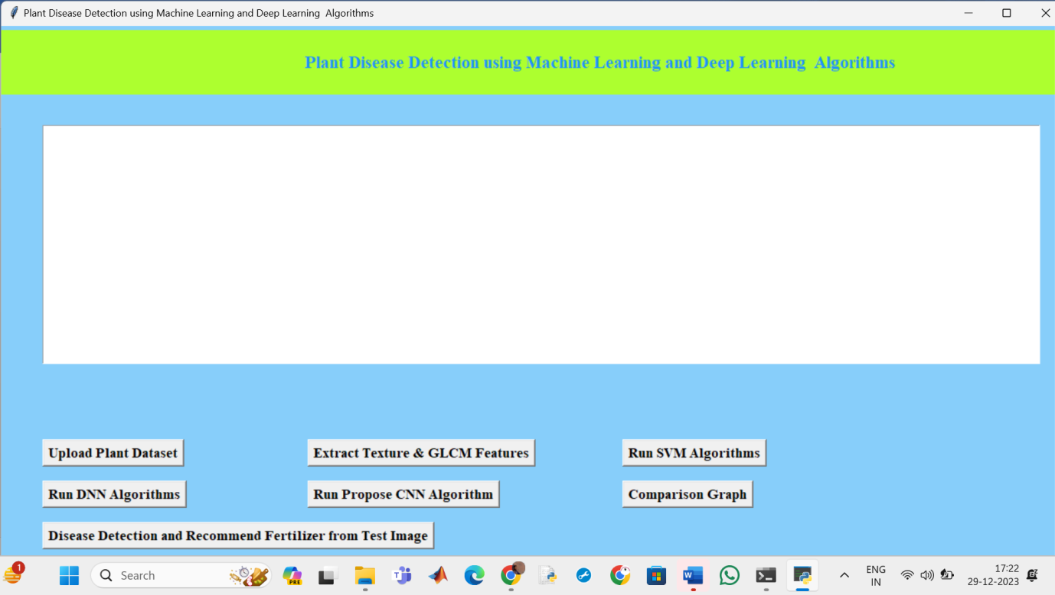

Figure 5: Basic GUI

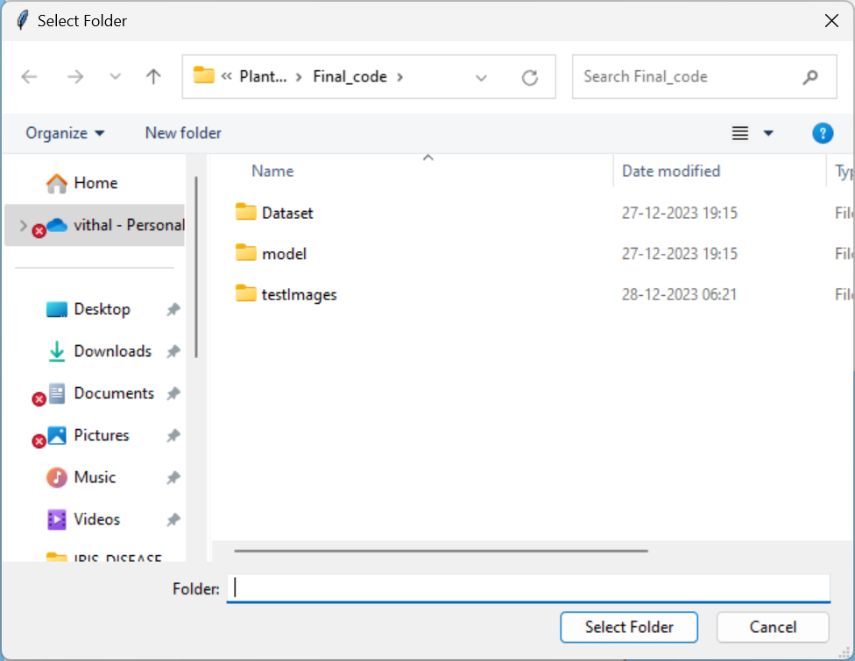

Figure 6: Selection of dataset folder

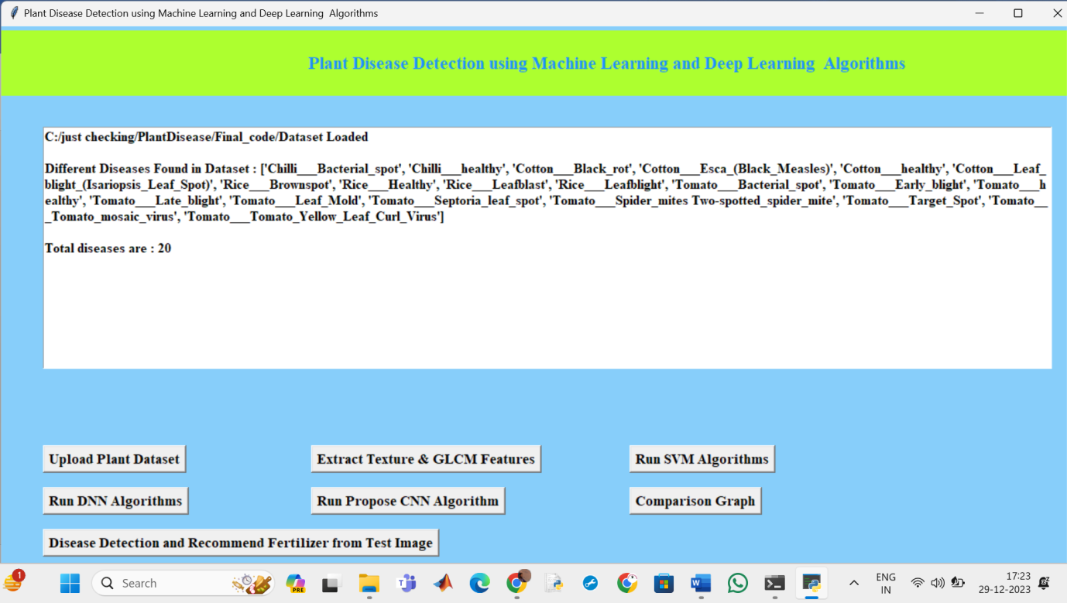

Figure 7: After selection folder

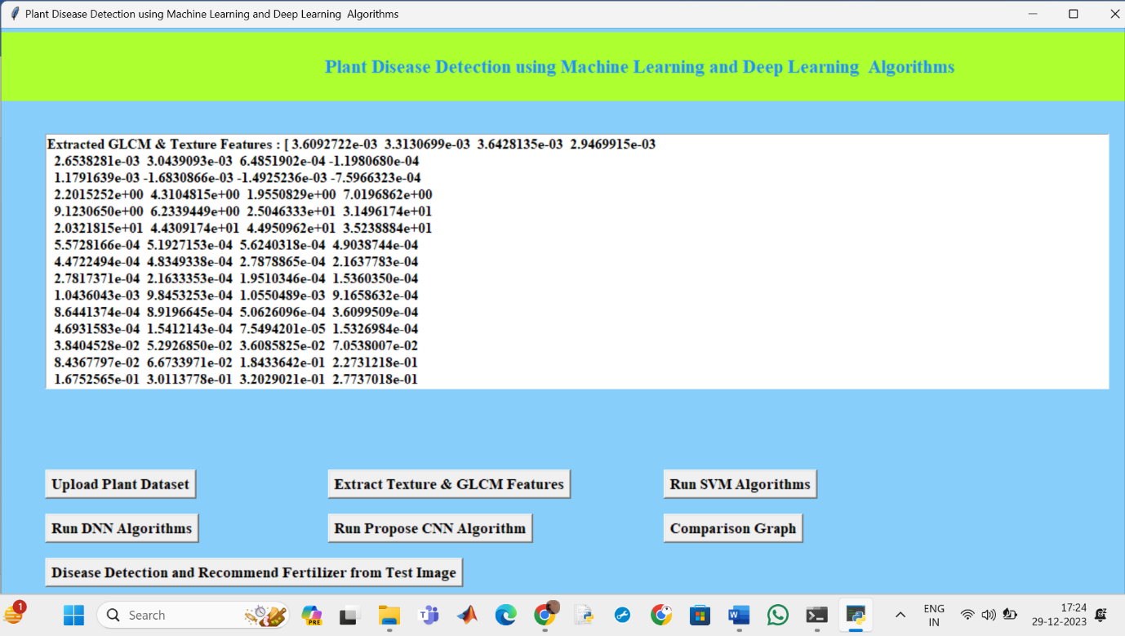

Figure 8: Feature Extraction
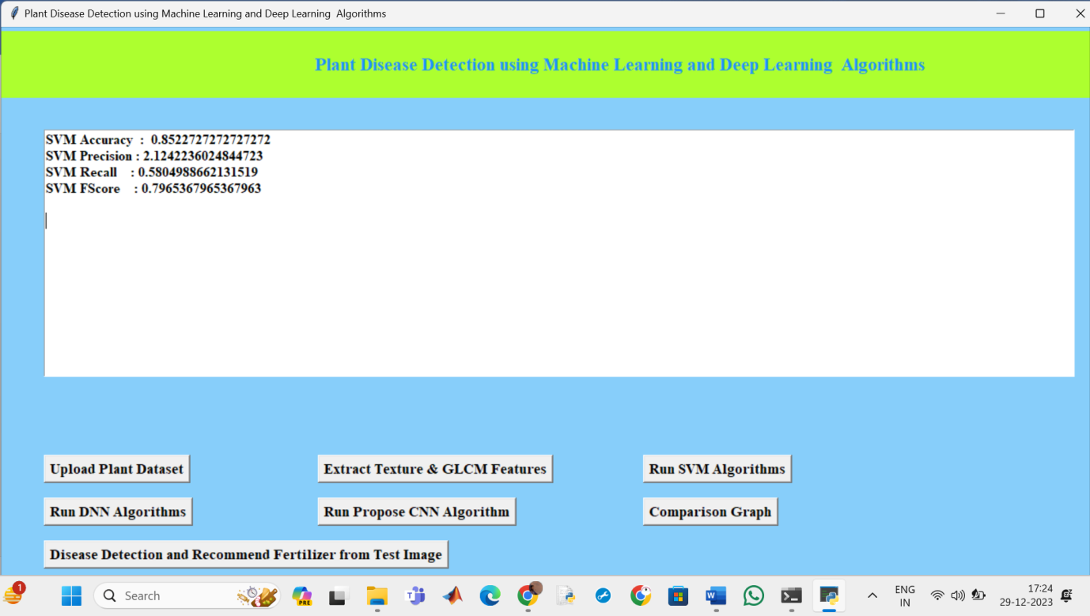

Figure 9: SVM classifier results

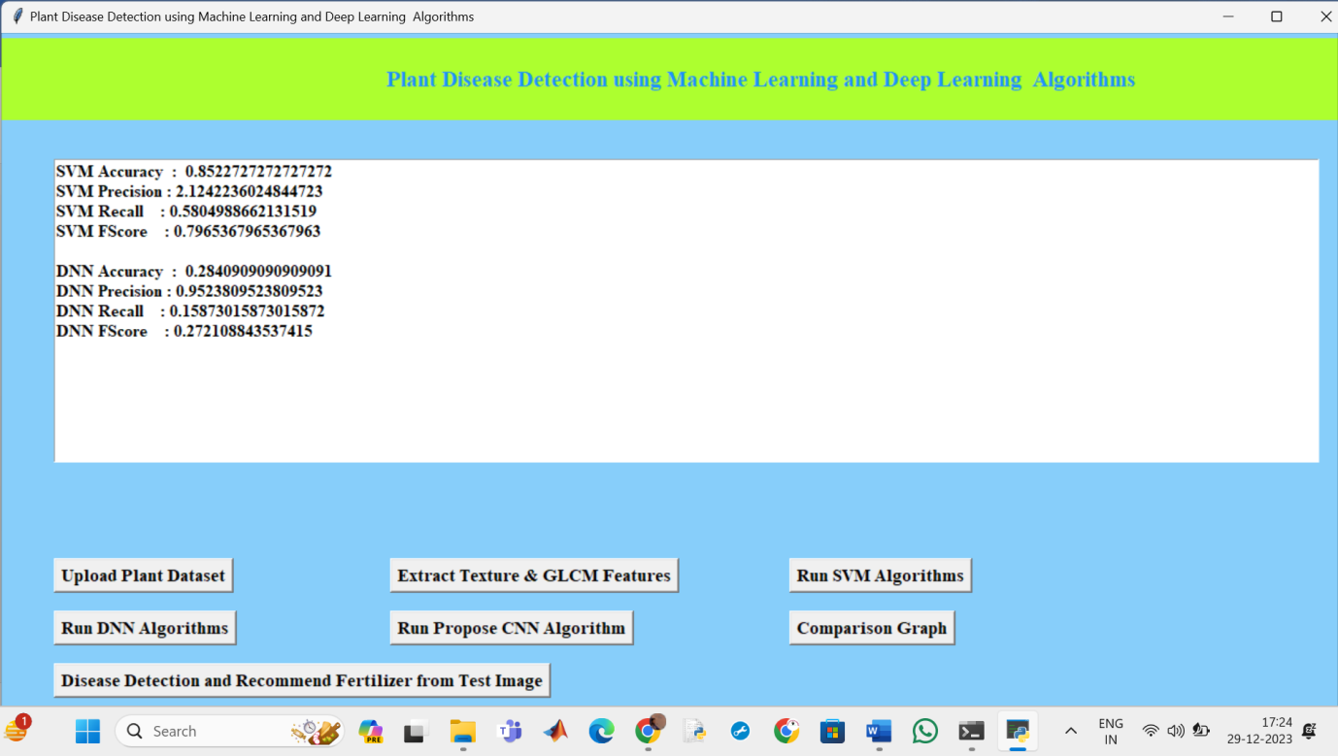

Figure 10: DNN classifier Results
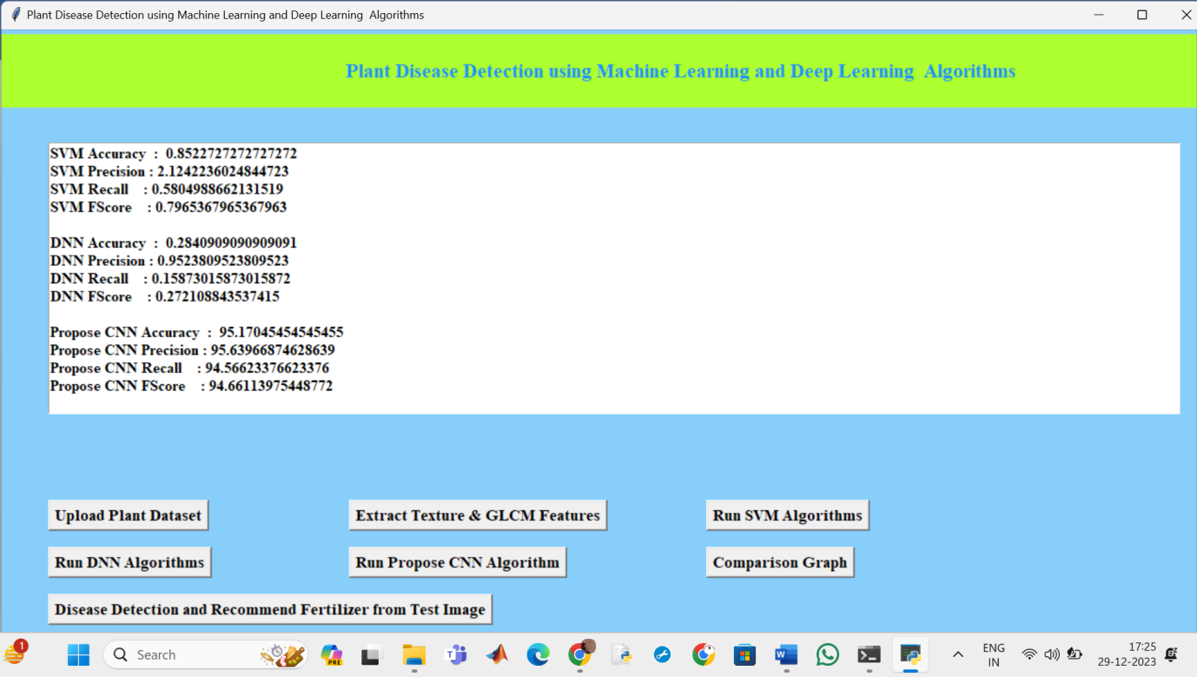

Figure 11: CNN classifier results

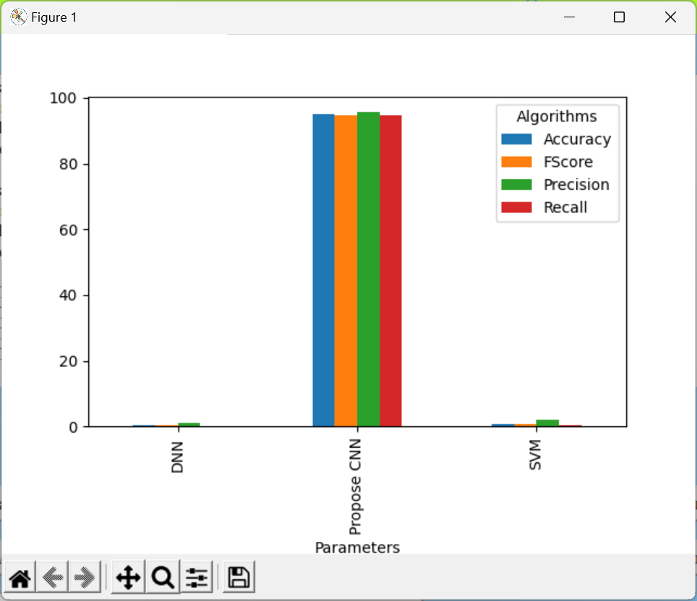

Figure 12: Comparision Graph

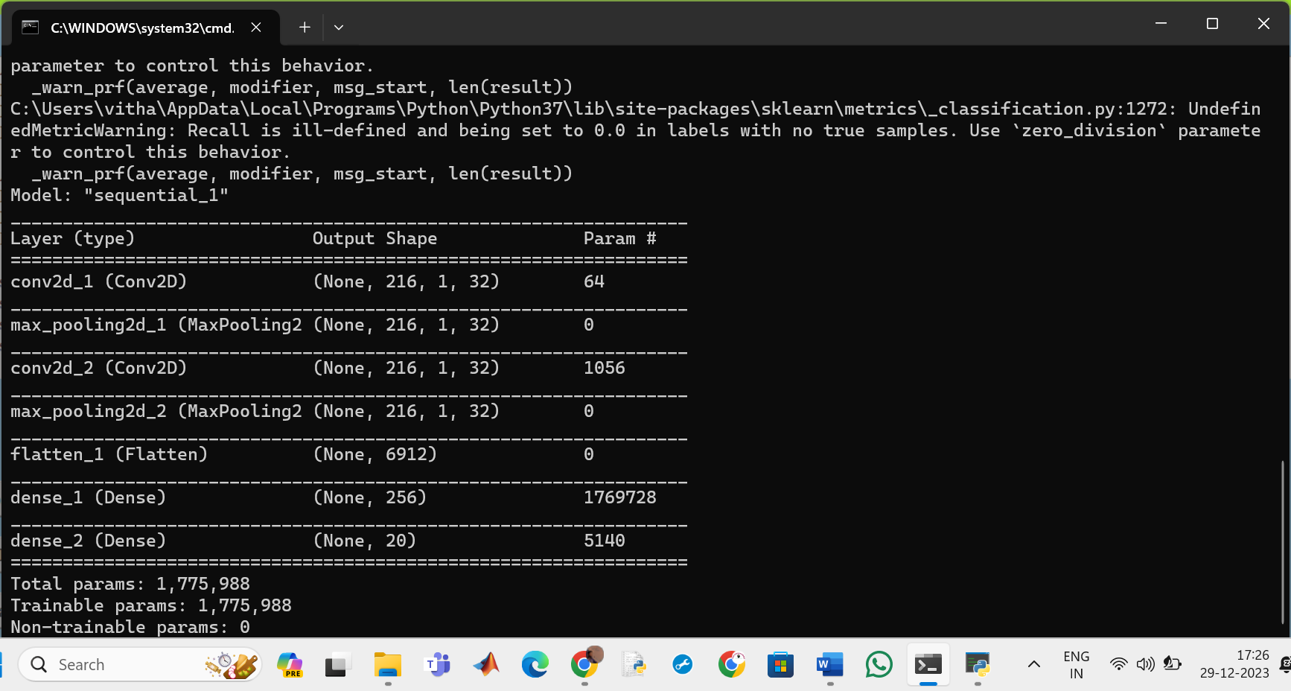

Figure 13: CNN structure

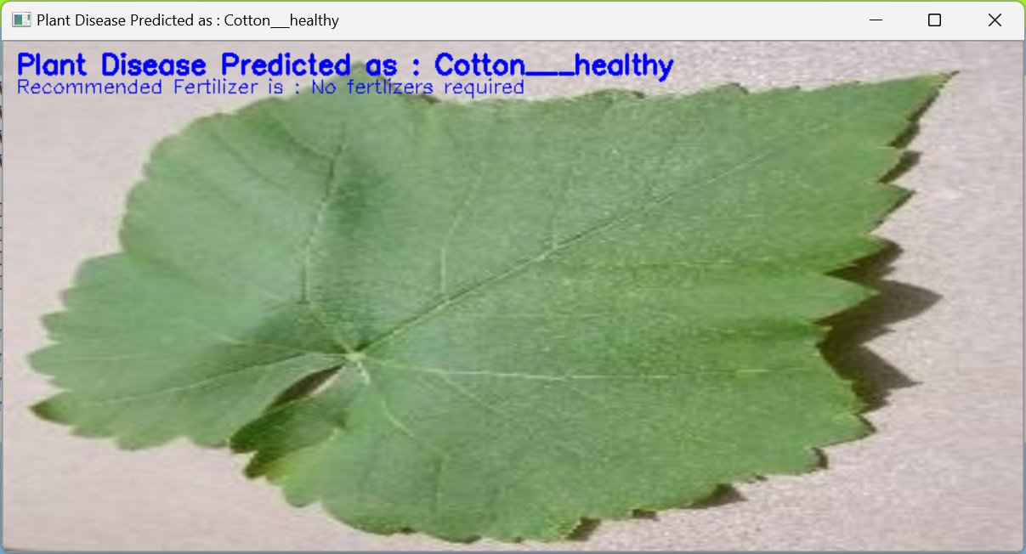

Figure 14: Plant regonised1

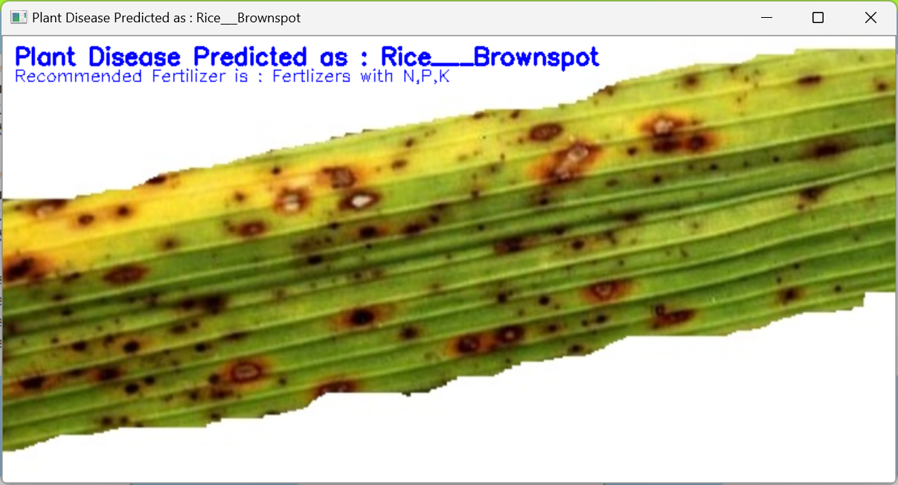

Figure 15: Plant regonised2

CHAPTER-10: CONCLUSION

Leaf disease classification using Central Neural Network has been successfully analyzed using image processing method and classified using Neural Network to get the performance of the data. In this paper, for plant leaf disease detection, we are using four plants, such as chillies, cotton, rice, and tomatoes. The image processing method has been applied to 100 samples of leaf and the data based on color and area of unhealthy analysed. The objective to capture and analysis data from leaf images for classify healthy or unhealthy of the leaves of medicine plants was achieved using image processing method. From image processing method, algorithm of adjusted contrast, segmentation and features extraction is used to extract image and to get data. The three of the method are included in image processing method. The experiment results have been done using Central Neural Network. Multi-layer feed forward Neural Network which are multi-layer perceptron and radial basis function RBF are the structures of the network used to class healthy or unhealthy of leaves. In the final experiment, the result shows that the RBF network performs better than MLP network.

CHAPTER 11: REFERENCE

[1] United Nations, Department of Economic and Social Affairs, Population Division (2019). World Population Prospects 2019: Highlights (ST/ESA/SER.A/423).
[2] Savary, Serge, et al. "The global burden of pathogens and pests on major food crops." Nature ecology & evolution 3.3 (2019): 430.
[3] Mohanty, Sharada P., David P. Hughes, and Marcel Salathé. "Using deep learning for image-based plant disease detection." Frontiers in plant science 7 (2016): 1419.
[4] Fujita, E., et al. "A practical plant diagnosis system for field leaf images and feature visualization." International Journal of Engineering & Technology 7.4.11 (2018): 49-54.
[5] Haralick, Robert M., Karthikeyan Shanmugam, and Its' Hak Dinstein. "Textural features for image classification." IEEE Transactions on systems, man, and cybernetics 6 (1973): 610-621.
[6] Cortes, Corinna, and Vladimir Vapnik. "Support-vector networks." Machine learning 20.3 (1995): 273-297.
[7] Cunningham, Padraig, and Sarah Jane Delany. "k-Nearest neighbor classifiers." Multiple Classifier Systems 34.8 (2007): 1- 17.
[8] Haykin, Simon. Neural networks: a comprehensive foundation. Prentice Hall PTR, 1994.
[9] Szegedy, Christian, et al. "Going deeper with convolutions." Proceedings of the IEEE conference on computer vision and pattern recognition. 2015.
[10] Duan, Kai-Bo, and S. Sathiya Keerthi. "Which is the best multiclass SVM method? An empirical study." International workshop on multiple classifier systems. Springer, Berlin, Heidelberg, 2005.
[11] Deng, Jia, et al. "Imagenet: A large-scale hierarchical image database." 2009 IEEE conference on computer vision and pattern recognition. IEEE, 2009.
[12] G. Wang, Y. Sun, and J. Wang, “Automatic image-based plant disease severity estimation using deep learning,” Computational Intelligence and Neuroscience, vol. 2017, Article ID 2917536, 8 pages, 2017.
[13] A. Kamilaris and F. X. Prenafeta-Boldú, “Deep learning in agriculture: a survey,” Computers and Electronics in Agriculture, vol. 147, pp. 70–90, 2018.
[14] K. P. Ferentinos, “Deep learning models for plant disease detection and diagnosis,” Computers and Electronics in Agriculture, vol. 145, pp. 311–318, 2018.
[15] R. I. Hasan, S. M. Yusuf, and L. Alzubaidi, “Review of the state of the art of deep learning for plant diseases: a broad analysis and discussion,” Plants, vol. 9, no. 10, article 1302, 2020.
[16] K. Lin, L. Gong, Y. Huang, C. Liu, and J. Pan, “Deep learning-based segmentation and quantification of cucumber powdery mildew using convolutional neural network,” Frontiers in Plant Science, vol. 10, p. 155, 2019.
[17] J. G. A. Barbedo, “Factors influencing the use of deep learning for plant disease recognition,” Bio systems Engineering, vol. 172, pp. 84–91, 2018.
[18] A. Ramcharan, P. McCloskey, K. Baranowski et al., “A mobile-based deep learning model for cassava disease diagnosis,” Frontiers in Plant Science, vol. 10, p. 272, 2019.
[19] A. Dhakal and S. Shakya, “Image-based plant disease detection with deep learning,” International Journal of Computer Trends and Technology, vol. 61, no. 1, pp. 26–29, 2018.
[20] S. Wallelign, M. Polceanu, and C. Buche, “Soybean plant disease identification using convolutional neural network,” in Proc. Thirty-First International Florida Artificial Intelligence Research Society Conference (FLAIRS-31), pp. 146–151, Melbourne, FL, USA, 2018.
[21] T. Wiesner-Hanks, E. L. Stewart, N. Kaczmar et al., “Image set for deep learning: field images of maize annotated with disease symptoms,” BMC Research Notes, vol. 11, no. 1, p. 440, 2018.
[22] K. Nagpal, D. Foote, Y. Liu et al., “Publisher correction: development and validation of a deep learning algorithm for improving Gleason scoring of prostate cancer,” NPJ Digital Medicine, vol. 2, no. 1, p. 113, 2019.
[23] V. V. Adit, C. V. Rubesh, S. S. Bharathi, G. Santhiya, and R. Anuradha, “A Comparison of Deep Learning Algorithms for Plant Disease Classification,” in Advances in Cybernetics, Cognition, and Machine Learning for Communication Technologies, Lecture Notes in Electrical Engineering, vol. 643, pp. 153–161, Springer, Singapore, 2020.
[24] A. Ramcharan, K. Baranowski, P. McCloskey, B. Ahmed, J. Legg, and D. P. Hughes, “Deep learning for image-based cassava disease detection,” Frontiers in Plant Science, vol. 8, article 1852, 2017.
[25] S. Verma, A. Chug, A. P. Singh, S. Sharma, and P. Rajvanshi, “Deep Learning-Based Mobile Application for Plant Disease Diagnosis: A Proof of Concept With a Case Study on Tomato Plant,” in Applications of Image Processing and Soft Computing Systems in Agriculture, pp. 242–271, IGI Global, 2019.

